Program-Project Management Skills 2

On business skills 2

My skills in business methodologies 2

On Project Management 2

Management Topics 2

Management Best Practices 2

My skills in leading and mentoring 2

On Work Breakdown structure 2

My system development skills 2

Experiences with OPS gating 2

Project governance 3

Documents that I generated to report 3

Knowledge of Technical Architecture 3

Strategic project management 3

Vendor Management 3

Portfolio Management 3

Program Complexities - Whole Solution 3

Components of Project Portfolio Management PPM 4

Portfolio, Program, Project 4

Organizational Project Management OPM 4

Portfolio Management principles & practices (10) 4

Portfolio Management Process Groups (5) 4

Portfolio Management Input & Output 4

Portfolio Management Tools & Techniques 4

Portfolio Management Organizational Context 5

Portfolio 5 Tiers of Work 5

Portfolio Processes 5

Project Portfolio Optimization (PPO) 6

Portfolio Metrics 7

Monte Carlo 7

Project Management 7

Overview 7

Responsibilities 7

Questions at Project Start 7

Checklist for Project Management 7

Project Metrics 7

Project estimation techniques 8

My expertise in tracking and reporting project financials 9

Earned Value 9

Project Processes and Tools 10

Recourse planning and Cost Management 10

Activities and Scheduling 10

CIBC Enterprise Delivery framework EDF 10

Gating processes 10

11 Control groups 10

EDF Phases and Responsibilities (v6) 10

EDF Mandatory Test Processes 11

Incremental Commitment Methodology 11

Microsoft Dynamics SURE STEP Methodology 11

PERT, CPM, GERT 13

MS Project 13

MS Project schedules 13

MS Project 7 steps to Build Realistic Schedule 13

MS Project Schedule Checklist 14

CIBC PLANVIEW PPM 17

CA-CLARITY 17

AGILE 18

Scrum schematics 18

Agile Questions 18

Agile methodologies 18

Agile Iterative, Incremental, Self Organizing, Emergent 18

Agile at DoD 18

Agile PMI-ACP 19

Traditional versus AGILE 21

Agile versus Waterfall 21

Microsoft DYNAMICS SURESTEP AGILE 22

System Integration 22

14 Integration Best Practices 22

Software Development Life Cycle (SDLC) 23

10 Phases of SDLC 23

Change Management 23

Generics 23

Keywords 23

FMEA Failure Modes Effect Analysis 24

Effective change process 24

Kotter’s Heart of Change 24

Change management specialist 24

Change In PMI Context 24

Change Management in Portfolio, Program, Project 24

Organizational Project Management (OPM3) 24

Change Management at Portfolio Level 24

Change Management at Program Level 25

Change Management at Project Level 26

Lean/Six Sigma 27

Activity-Based Costing 27

Booz Allen Cost Transformation 27

ABC Illustrated 27

ABC in Insurance 29

ABC in Banking 29

PeopleSoft Activity-Based Management PeopleBook 29

# Program-Project Management Skills

## On business skills

#### My skills in business methodologies

* **Business evaluation**: I performed the evaluation of business proposals based on financial metrics (ROI, NPV, etc.), alignment with organization mission and strategy, prioritized based on forecasted value, risks, impact on the organization and dependency to other initiatives - Used at HOOPP, 2010 to rank 300+ initiatives, Used at CIBC, 2009 to develop business case for Risk Initiatives
* **Business process methodology**: I am experienced in **Six Sigma** and Lean management. I am trained in many of the tools including: SIPOC, Voice of Customer, Voice of Process, Process Map, ANOVA, Cause-Effect, Cost of poor quality CoPQ
* **🕮PM Tool KIt**

## On Project Management

#### Management Topics

AGILE, 90 AGILE Questions, 90 Business requirements, 15 Change, 11 Data skills Checklist for Project Management, 79 CIBC PLANVIEW PPM, 85 Financials, 80 Gating, 74

Governance, 75 Leading and mentoring, 74 Meetings, 11 MS Project, schedules, 85 Project estimation, 80 Quality Management, **Error! Bookmark not defined.** Questions to ask, 79 SDLC, 74 Stakeholders, **Error! Bookmark not defined.** Status, 75 Technical reviews, 11 Timelines, 11 Vendors, 75 Work Breakdown structure, 74

#### Management Best Practices

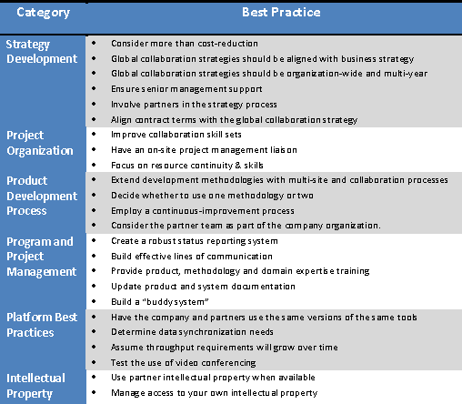

#### My skills in leading and mentoring

➊Team Management ➋Principles for leading ➌Coaching ➍Emotional Intelligence

#### On Work Breakdown structure

Product-oriented, 100% rule, documentation, WBS and EVM and Risk management

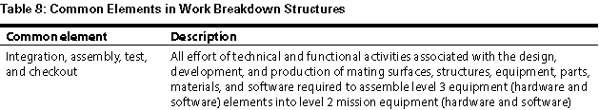

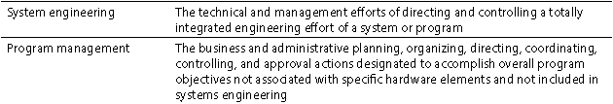

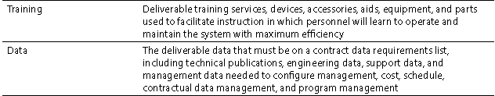

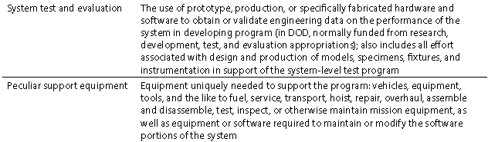

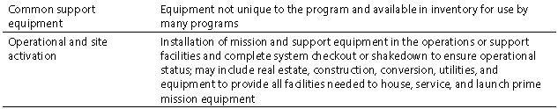

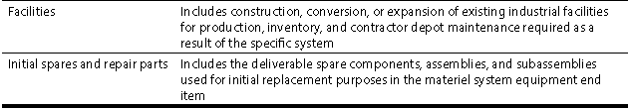

##### WBS Example

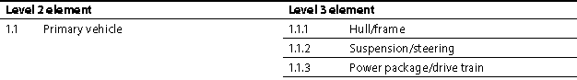

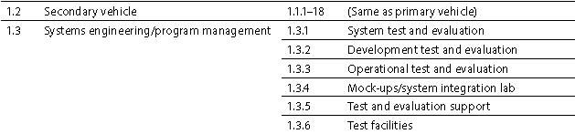

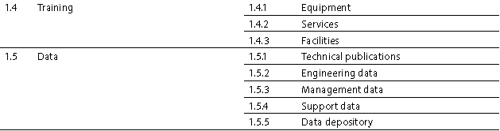

#### My system development skills

##### Planning Methodology

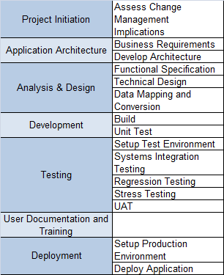

##### Development projects

➊**RSI OLSM Accenture** 1.2M **Optimized Least Squares Monte Carlo (OLSM**) to reduce the computational burden of pricing instruments (using FO models require too much resource) plus non-vendor risk system - **Payout Module** to push out P/L vectors

Contract 1: July 220K Initial market risk / counterparty risk OLSM design

Contract 2: Aug 220K Additional: CVA design & prototype interface code

Contract 3: Sep 108K Prototype analytics code and demo

**❷OSFI a) IRC work stream b) MRA Stressed VaR c) MRA Enhanced VaR** (IR basis risk, correlation risk, dividend risk, etc., volatility scaling)

**❸HOOPP** **SIMCORP**team of 5 business analysts and vendors and a pool of 10 developers in the transition to production of SCD; converted a **backlog** of over 300 business requirements in collateral management, investment accounting, and treasury operations into a coherent goal for 3 **iterations** of **20,000 man-hour**, each with an **iteration plan** made of **sprints** of 3 weeks each ending with a testable deliverable based on a well-developed **user story**, itself part of an **epic** or **feature** – **End product**: integration of portfolio management, trading, risk management and performance attribution

#### Experiences with OPS gating

**Gate 0**-Project Feasibility **Gate 1**-Review & Approval Dependant on Value/Risk **Gate 2**-Definition Phase, Project **Gate 3**-Planning Phase, Integrated Project Plan **Gate 4**- Implementation Phase, User Acceptance Documents **Gate 5**-Close out Phase

⬩Gate 0 and 1: CMA, MBA and Masters of Research, Consulting training ⬩ Gate 2, 3 and 4: PMP, Consulting training, Commercial IT development background, CISA IT auditing ⬩ Gate 5: ITIL, CISA IT auditing ⬩Selected projects with gates **HOOPP (2012) Accounting Analytics** Gate 0 ⇨ 5 **CIBC (2009) Risk Initiatives** Gate 0 ⇨ 3 **MANULIFE Derivatives Accounting (2009)** Gate 2 ⇨ 5 **CIBC–Secure End User Computing SEUC (2008)** Gate 0 ⇨ 3 **CIBC-Mellon (2007) Financial System Renewal Project FSRP** Gate 0 ⇨ 3 **CIBC Internal Control Repository ICR (2003):** Gate 2 ⇨ 5

#### Project governance

•**Main activities** (➊ program direction ➋ownership and sponsorship ➌ensure effectiveness ➍reporting and disclosure, consulting with stakeholders)•**Compelling business case** (project objects, in-/ out-of-scope)•**Assess compliance** against original objectives •**Identify stakeholders** with interest in project •**Defined method of communication** to each stakeholder •**Agreed business-level requirements** by all stakeholders•**Agreed project deliverables** •**Appointment of project manager** •**Clear project roles/ responsibilities** •**Current, published project plan** spanning all stages •**Accurate status/ progress-report** with time records•**Central document repository** for project•**Central glossary** of project terms •**Process for management and resolution of issues** •**Process to record/ communicate risks** •**Standard for quality review** of key governance documents and of the project deliverables

##### Project governance tools

**➊Dashboard weekly** (Minutes & Action Items from Steering, Discussion Points, Green/ Yellow/ Red Status by Work Stream, 90-Day Plan, Critical Milestones) ➋**PMO Handbook** (Scope Summary, Program Approach, Program Management Control Process, High Level Integrated Program Plan, Project Critical Milestones, RSI Governance, **Appendices** Roles & Responsibilities, Weekly Status Report Process, Change Control Purpose & Responsibilities, RSI SharePoint, Project Control Mechanism, Centralized Issues Log)

🕮**Tools & Techniques for Management, Change** **–** **DMAIC Tools Map****,** **Constraint Analysis****,** **Cause and Effect****,** **Check list****,** **Fault Tree Analysis****,** **Root Cause Analysis****,** **Risk Breakdown Structure****,** **Probability and Impact Matrix****,** **Probability and Impact****,** **Risk Heat Map****,**

#### Documents that I generated to report

**⬩Management Summary**: achievements since last report, is the project on target to meet the delivery date and the budget? If not, discuss the reasons and risks; and approaches/ requirements to get the project back on track ⬩**Key milestones:** Planned completion date (baseline), Currently projected completion date, Actual projection date ⬩**Risk register:** risk description, current mitigation plan, contingency plan, likelihood of occurring, potential impact ($ / schedule / quality etc) ⬩**Change request history**: estimated cost in $, estimated effort (man-days), schedule change (if any), status (in review, agreed, withdrawn ⬩**Key project metrics:** application features (planned, developed, tested, accepted), change requests (new, approved, closed), project staff (current-planned, turnover rate) ⬩**Financials**: on labor, expenses, material, contingency per to-date, planned (baseline), currently projected

#### Knowledge of Technical Architecture

**UML**, certified SUN Java Enterprise Architect, Open Group [**TOGAF**](#_TOGAF_(Open_Group)**,** **dot-NET** architecture

#### Strategic project management

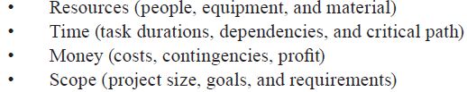

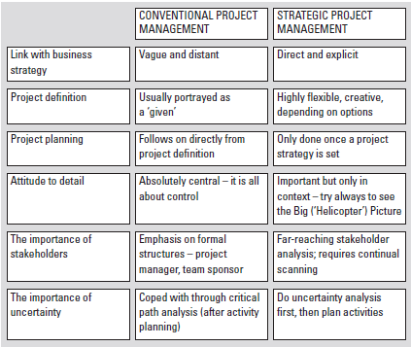

#### Vendor Management

•**Spiel (COBIT)** ➊**Review RFIs + RFPs** (⬩requirements definition ⬩procedure to clarify requirements ⬩sufficient time for vendors to prepare proposals ⬩award criteria + decision process definition) ➋**Evaluate RFIs+ RFPs+ contractor performance** per approved evaluation process/criteria to identify opportunities/ need to replace ⬩Maintain **documentary evidence** of evaluations ➌**Produce reports to monitor** problem resolution against business requirements and SLAs ⬩Ensure **escalation of problems per agreed criteria** (to higher management level, external vendors, change advisory board to increase priority of urgent request for change (RFC) for temporary workaround) ➍Regularly **review & evaluate information on new potential threats** (e.g., reviewing vendors’ products and services security) ⬩**Off shoring** Chennai: 1,000 Indian IT Tata Consulting Service **Factors** Project/ Client Maturity (•Interaction process •Development process •Requirements/ specifications •Platforms/ technologies •Tools) System Complexity (•Data model •Functionality •Types, # interfaces) **Lessons** ➊Follow/ respect methodology & working process ➋Define handover points, entry/exit criteria, deliverables ➌Plan technical connectivity early ➍Plan well ahead, involve off-shore team ➎One Team, not “us and them” ➏For larger, more complex engagements, embed onshore solution skills/ management strength into offshore location ➐Aware Off shore culture, public holidays, religious practices ⬩**Communication layer** •Communication Protocols •Communication Infrastructure •Email and IM •Skype •Face-to-Face Meetings •Optimizing Time Differences •Big Challenge •Schedule Meetings at Overlapping Times •**Vendor intelligence** ❶Client references ❷Technology architecture (SW, HW, communications, storage, security) ❸Current/future roadmap ❹Documentation ❺Development ❻Management/ support •**ASP Concerns** (Data Security, Application Availability/ Performance, Application Integration, Vendor’s Stability/ Longevity, Customization, Loss of Control, Bound by Contract) ASP Certification and Insurance

##### Specific skills

⬩Build, maintain constructive relationships with internal business partners, suppliers & service providers ⬩Manage & administer supplier and service provider contracts in accordance with **Bank’s Outsourcing Model** ⬩Ensure supplier & service provider **policies and procedures (P&Ps)** meet Bank legal, control, audit, compliance, risk/privacy mandates and security requirements, comply with regulatory and Bank requirements ⬩Provide day-to-day oversight of supplier/service provider services, ensuring adherence to all contracted service levels ⬩Evaluate overall **merits of contracts** ⬩Participate in contract renewal negotiations, provide **Service level agreement SLA**, **Technology service agreement TSA,** **Business Partnership agreement BPA** ⬩Prepare quarterly **management interpretation documents** ⬩Complete & submit **annual outsourcing attestation** ⬩Act as escalation point for internal business

🕮**Contract Baseline (8 elements)**🕮**Vendor Selection** 🕮**ITIL**

## Portfolio Management

#### Program Complexities - Whole Solution

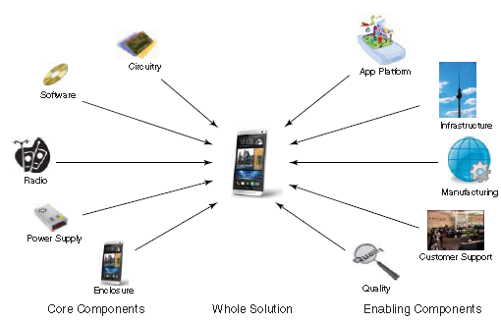

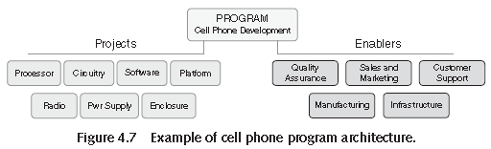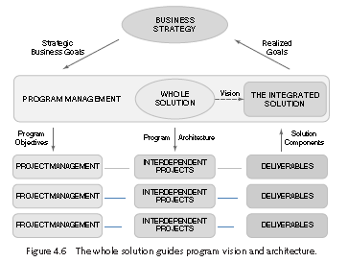

#### Components of Project Portfolio Management PPM

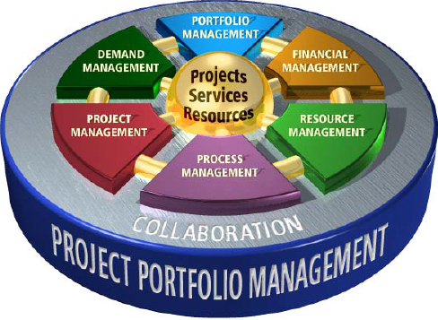

#### Portfolio, Program, Project

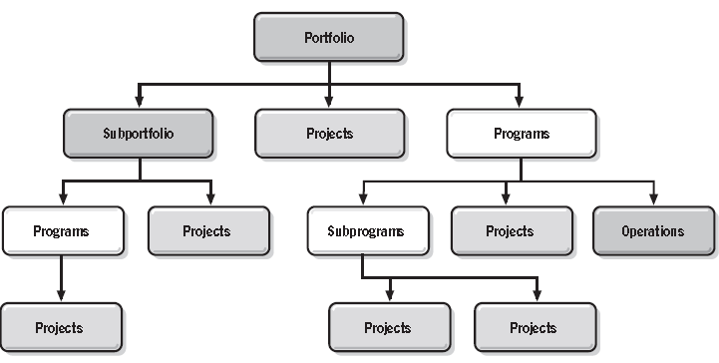

#### Organizational Project Management OPM

##### OPM and Change

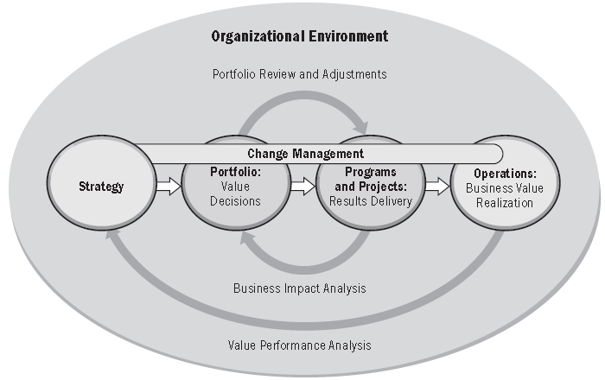

##### OPM and Change Timeline

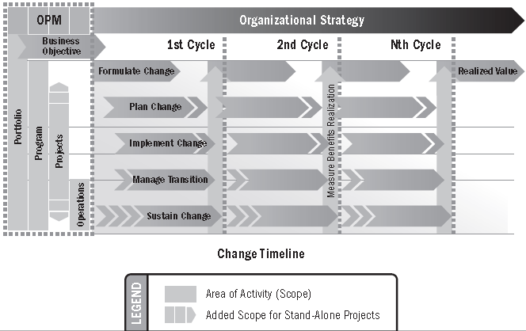

🕮**Program Management Process (Ricardo Vargas**)

#### Portfolio Management principles & practices (10)

➊**Strategic focus** ➋**Strategic initiatives** ➌**Portfolio Components** ➍**Quantifiable Components** ➎**Time Horizon** ➏**Portfolio snapshot** ➐**Portfolio Management Activities** ➑**Alignment to Organization Strategy** ➒**Governance** ➓**Balancing of conflicting demands**

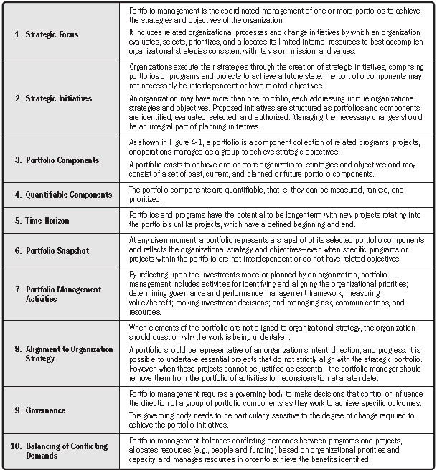

#### Portfolio Management Process Groups (5)

➊**Strategic** ➋**Governance** ➌**Performance** ➍**Communication** ➎**Risk**

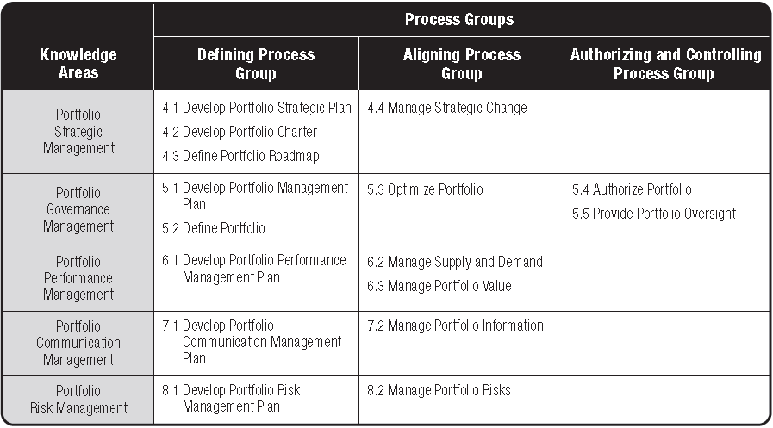

#### Portfolio Management Input & Output

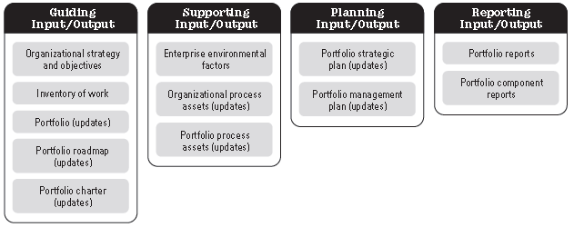

Portfolio Management Tools & Techniques

➊Analysis ➋Selection ➌ Meeting ➍Communication

##### Analysis Tools & Techniques (15)

➊Strategic alignment ➋Prioritization ➌Scenario ➍Capability & Capacity ➎Interdependency ➏Cost/benefit ➐Stakeholder ➑Readiness ➒Portfolio Organizational Structure ➓Graphical Analytical Tools ➊Quantitative & Qualitative ➋Value Scoring & Measurement ➌Benefits Realization ➍Communication Requirements ➎Gap

##### Selection Tools & Techniques (4)

➊Portfolio component inventory ➋ Portfolio component categorization ➌Weighted ranking & scoring ➍Portfolio authorization

##### Meeting Tools & Techniques (1)

➊Portfolio review meetings

##### Communication Tools & Techniques (4)

➊Communication methods ➋Elicitation techniques ➌Portfolio Management information system ➍Integration of Portfolio Management

#### Portfolio Management Organizational Context

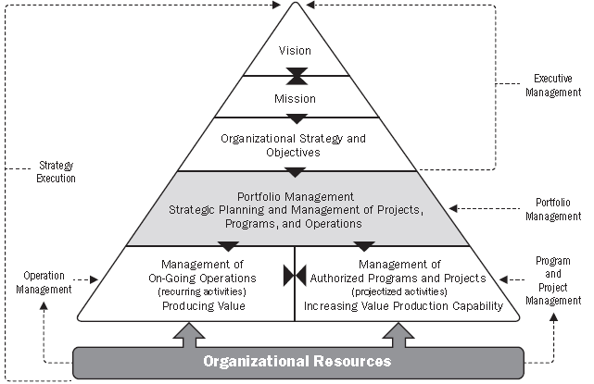

#### Portfolio 5 Tiers of Work

➊Operations ➋Lights on ➌Regulatory Mandated ➍Partner Requests/Deamand ➎Grow and Transform (>$10K, 200 hours)

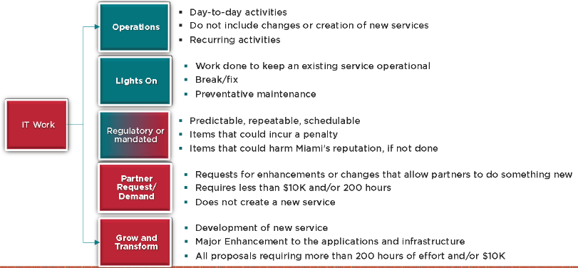

#### Portfolio Processes

##### Proposal > Project > Benefits

➊**Proposals** ⬩Business drivers prioritization ⬩Business case (strategic & financial benefits) ⬩Portfolio analysis/ optimization ⬩Resource/ Capacity Planning/ What-If Analysis ⬩Portfolio balancing schedules-skills ⬩Portfolio Selection ➋**Project** ⬩Planning/ scheduling ⬩Resource assignment ⬩Project tracking ⬩Time reporting ⬩Resource Management ⬩Status Reporting ➌**Benefit** ⬩Portfolio investment tracking ⬩Performance tracking ⬩Benefits realization tracking ⬩Risk analysis ⬩Project lifecycle cost tracking

##### Governance

Group initiatives into portfolio in order to ➊**Support business segment, product, product line** ➋**Manage investments** continuing oversight/ decision-making about which initiatives to undertake, continue, reject or discontinue

##### Goals > Strategies > Projects

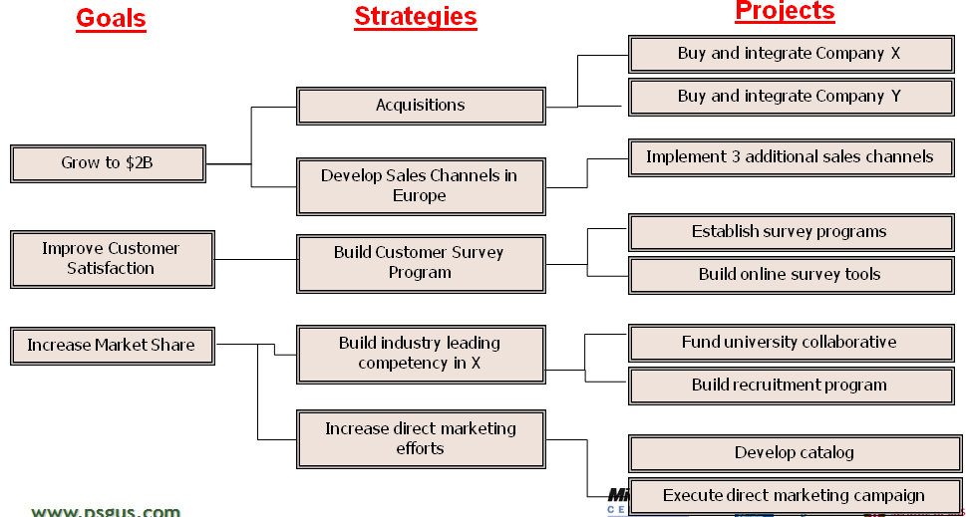

##### Pairwise Comparison

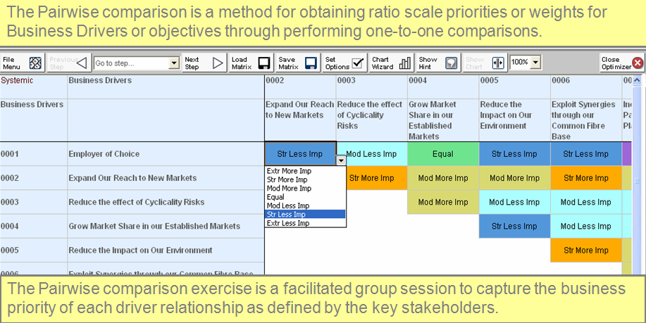

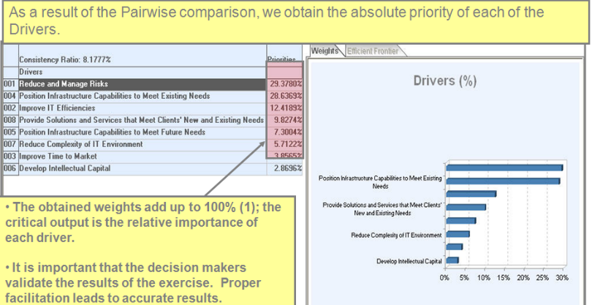

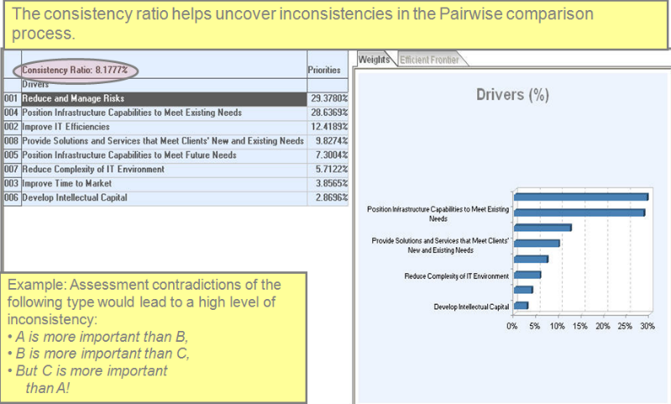

##### Scenario analysis

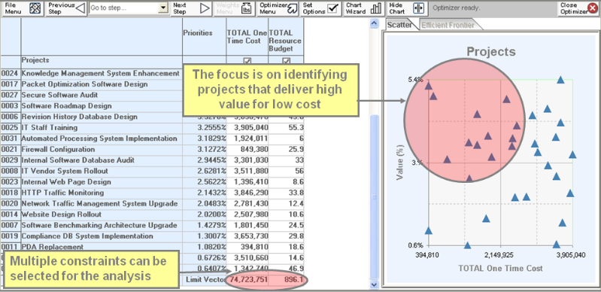

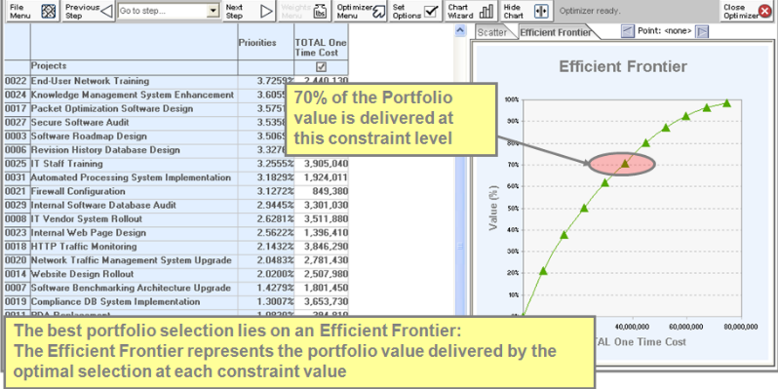

##### Input to Efficient Frontier Analysis

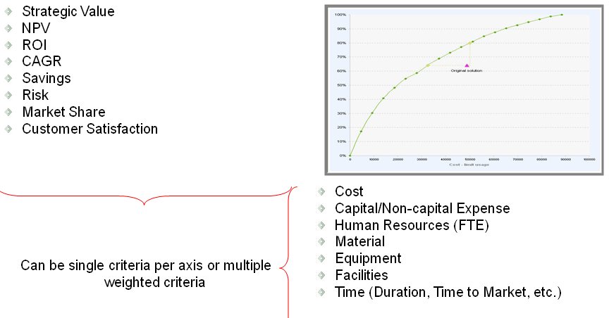

#### Project Portfolio Optimization (PPO)

##### PPO Dashboard (from PwC)

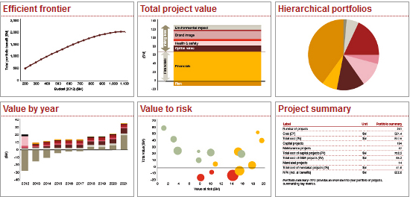

##### Efficient frontier

⬩**Efficient frontier** illustrated results of funding different combinations of projects that deliver greatest possible value for given level of investment

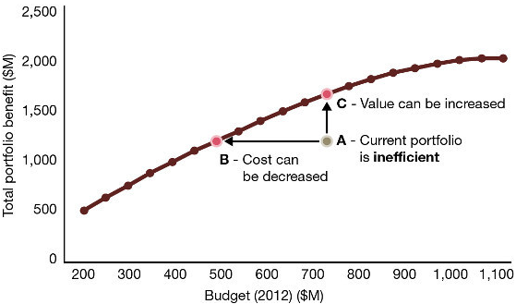

##### Total Project Value

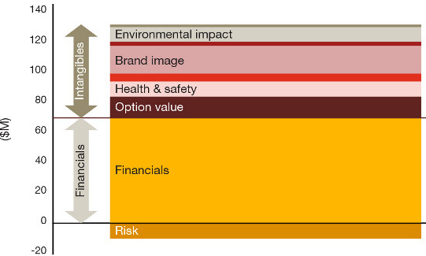

⬩**Value creation** = incremental revenue + cost savings + indirect benefits (brand value, health and safety improvements, environmental impact, sustainability, stakeholder perception) + "*Real Option Value*" (management's ability to change course with project)

##### Hierarchical portfolios

⬩Prioritize funding regardless of where decisions are made (centralized at corporate level or decentralized at business unit level) ⬩Centralized optimization ⇨ resources redeployed across business units as needs arise (final resources allocated to each business unit = output of value, not a constraint set up front) ⬩Decentralized organizations ⇨ resources, budget divided among business units; funding based on historical precedent, strategic importance or growth expectations; resulting portfolios be aggregated and analyzed

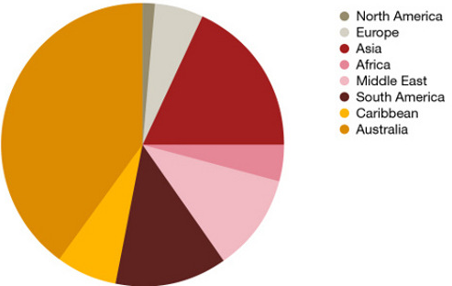

##### Value by year

⬩Project’s value components change over time ⬩Value equation includes number of dynamic variables that can change over time ⬩Initial investment usually front-loaded while benefits take time to develop. PPO lets you project and compare the value of projects by year or the time interval you choose. You can see total value as well as the components of value and how each changes over time. With a more complete view into value, you can deploy capital more efficiently to support your organization’s long-term strategy.

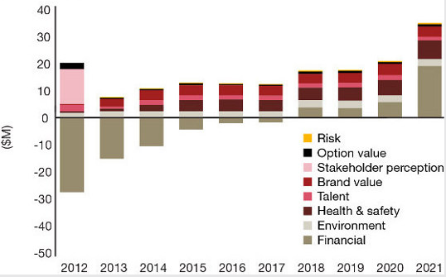

##### Value to risk

Which projects are worth the risk? Quantify risks so you can prioritize projects based on their value to risk. You can compare – on a level playing field – the risks assumed. You’ll have a basis for considering – and defending -- which projects are worth the risk.

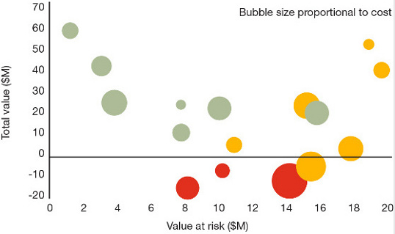

##### Project dependencies

⬩How to prioritize foundational projects ⬩Which projects to take priority ⬩Highest benefit-to-cost ratio/ *foundational projects* ⬩Make project portfolio funding decisions based on cumulative impact on organization's goals ⬩Graphs illustrate how Project P overlooked for funding because low cost-benefit ratio. But when dependencies are considered, Project P takes a much higher priority because it enables other, more beneficial projects

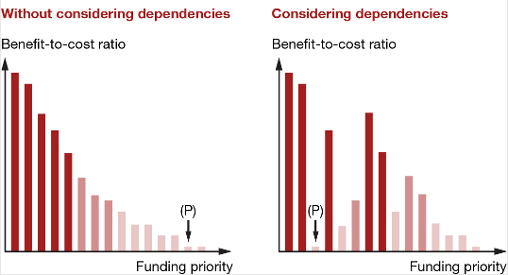

##### Roadmap to PPM Maturity

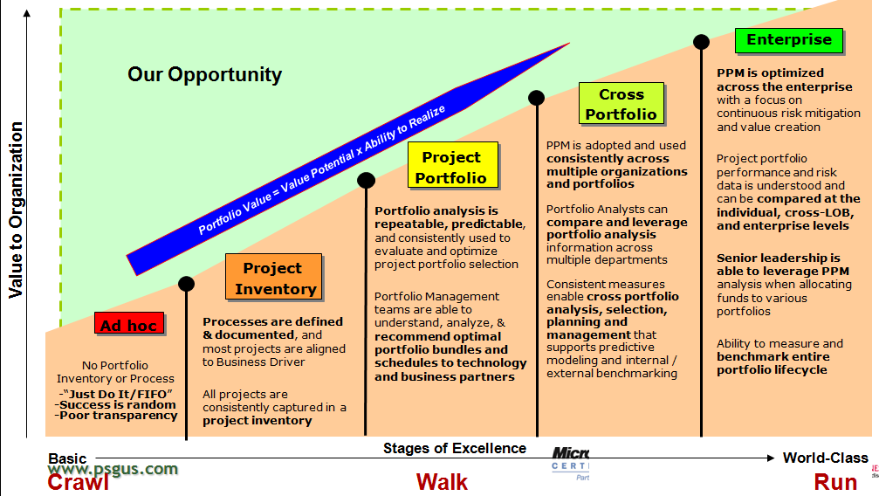

#### Portfolio Metrics

|  |  |  |
| --- | --- | --- |
| **Category** | **Key Question** | **Sample Metrics** |
| **Portfolio Mix** | Is our funding aligned to strategic objectives | % portfolio spend in “run the business,” “grow the business,” and “innovate the business” [could use other [portfolio models, like the one from MIT CISR](http://cisr.mit.edu/research/research-overview/classic-topics/it-portfolio-management/)]; % of Portfolio in Short/Medium/Long-term Projects; % of Portfolio in Large and Extra Large Projects |
| **Demand & Capacity** | Do we have the right prioritization and sequencing of projects given capacity? | % growth in project intake, % growth in initiatives, IT resource utilization, business resource utilization, recruiting pipeline |
| **Value** | For our portfolio, to what extent did we achieve our objectives? | % on time, % on budget, Portfolio and Sub-portfolio IRR, # function points delivered vs plan, $ saved for consolidation efforts |
| **Portfolio Health** | For projects in-flight, how is our execution progressing? | counts and amounts for projects in Red/Amber/Green status; #issues by severity: opened, closed, on-hold |
| **Financial Management** | How effectively are we managing project budgets and what are financial trends? | % variance to plan, % funding in-flight; $ committed but not spent; earned value |

## Monte Carlo

**What For?** ➊Critical Path / Time to Market Analysis ➋Project Cost Estimation ➌Workforce Planning with Queuing ➍Schedule Risk Analysis **Input Distributions** ➊**Normal** ➋**Exponential** for inter-arrival times ➌**WEIBULL** for component life/failure times ➍**Lognormal** for cycle times ➎**Poisson** for the number of events in a given time interval ➏**Triangular** distribution

# Project Management

## Overview

#### Responsibilities

**Tasks** •Project estimation, quality, planning, risk, issues management, reporting and stakeholder management **Services/activities** •Deliver project plans/ integration, issues/ risk management, financial management •Manage project scope, quality, schedule/ change control processes •Manage development of project plan deliverables •Manage critical processes (requirement gathering/ solution design) •Responsible for chairing status, issues/ risk meetings •Day-to-day management •Lead project procurement/ contract management •Ensure knowledge transfer **Deliverables** •Integrated project plan •Project issues •Project change management status •Project risks •Weekly Status Reports •PMO Status Reports •Integrated plan •Project issues •Project change management status

#### Questions at Project Start

##### Why-Who-What-When-How

**Why?** Why are we doing this project? What are the goals? How do these goals align with institutional, school, or department strategic goals? Why are we initiating this project now?

**Who**? Who is the client for the project? Who is the project sponsor? Who will the customers and stakeholders be? Who is the team that will be supporting the project after launch? Which operations will this project impact? Who is providing the resources for planning, managing, and supporting this project? Who will be responsible for communicating with stakeholders about the project? Who do we need to communicate with during the planning, running and evaluation of the project?

**What**? What are the resources being devoted to the project? How many FTEs? How many dollars? Which team members will be assigned? For how long? What is it okay not to do (opportunity cost) due to this project? What do we expect to learn? What are we not doing by starting this project? What would be the costs and benefits of not starting this project? What are the risks? What other questions about this project should I be asking?

**When**? When will the project go live? When will we start communicating about the project? When will the resources that are needed be secured? When will we have a window to initiate this new project given current operational needs? When can we manage any scheduled downtime that this new product or service may cause?

**How**? How do we plan to recoup the costs (direct, indirect, and opportunity) for the project? How will this project be evaluated? How will we prioritize this project within our portfolio of other projects? How will we manage any changes that will result from this project? How will we recognize, communicate, and mitigate the risks?

##### My Boss

•What is the current status of the project? •Is there a statement of work and project plan I can review? •Where are the contracted deliverables and timelines? •What does success look like for my role? •Who are the main clients and how do you see me interacting with them? •Who are the firm executives on the account and what are their roles? •What politics should I be aware of? •What documents should I review first? •Who should I meet with to get up to speed quickly? •What do I need to tackle first this week?

##### Practical

•Where is project team located? •How do we set up meeting? (Outlook invitation, meeting room set up, conferencing, Etc) •Is there a shared workspace or SharePoint for the account/project team? •Are there specific templates that should be used for deliverables?

##### Stakeholders

•Why are you doing this? •What are your assumptions? •Who is your audience and what do they want? •What is the follow-up plan? •How do you define success? •What are the perceived risks? •Who is the main stakeholder? •Who is responsible for ensuring appropriate resources (time, people and money)? •Who will be responsible for deciding whether the project goes ahead or not?

##### Planning

•What are the major deliverables for this project? •What are the major steps in my project plan? •How detailed should the plan be to put deliverables in perspectives? •How experienced/mature is the organization in its project management approach? •What is the project delivery methodology? •Which tool is used for planning? •How rigorous is the time reporting? •Are there templates for management reporting?

#### Checklist for Project Management

•Clear, concise **statement defining the program** prepared & reviewed by knowledge parties for consensus •**Performance objectives** follow guidelines with actual calendar dates for completion •**Work Breakdown Structure** developed to a level sufficient to prepare accurate estimates of cost, resources and working times for all program activities •Statement of **program scope** that clearly defines the limits of what will and what will not be done or delivered as a result of the program •**Specifications** identified and "owners" of these specifications concur with the outcomes •**Tangible deliverables** identified for milestones for performance measurement •**Responsibility Assignment Matrix (RAM)** showing involvement of key contributors •**Working schedule** with allocated resources showing how these resources will be applied over time to produce the project or service from the program •**Critical Path & Program Evaluation Review Technique** basis for all performance reporting, working schedules, and known dependencies •**Spend plan** that shows cash flow throughout the program’s duration •Strengths, Weaknesses 🞧 Opportunity and Threats (**SWOT) analysis** on program risk •Where **risks** have been identified, **contingency plans** have been started to deal with them as well as a risk register to tract the potentials for the risk becoming a problem •If capital equipment is needed in the program, appropriate **requisitions** have been prepared, with cost justifications attached •**Program plan** prepared with participation & input from the deliverables owners •**Control system** established using variance analysis to assess performance •All components of program measurement system are as defined in **Earned Value Management System** or an appropriate measure of physical percent complete •Individuals have been selected for assignment to the program whose individual needs will be met through participation, where possible •The program is planned to a manageable level of detail at no less that level 3 of the **work breakdown structure (WBS)** •Work has been broken down into reasonable durations tasks (work packages) which are assigned with a budget and to a responsible **Control Account Manager** •A post-mortem has been done at each **milestone** in the program and a final one has been done for the overall program and placed in the program •Team instructed to **record their working times** on the program daily •**Chart of control accounts** (level three of the WBS) has been developed to track earned value against the plan and the contract deliverables of the program •All members of the team are clear on the **expectations** of them in terms of authority, responsibility and accountability •Standard **operating procedures for empowering** people has been applied to every member of the team •**Limits** established to determine when the program plan will be revised, such as plus or minus 10% total authorized budget variation, etc •**Needs of customers** carefully considered and documented in preparing the program plan •**Qualitative guides** developed for non-quantifiable program objectives, such as program performance •Checklists prepared for major segments of the program avoiding overlook

#### Project Metrics

##### JP Morgan 5 Project Metrics

➊Effort level by phase ➋Project variances ➌Productivity rate (Phase effort/Project size in functional points) ➍Defect counts ➎Functional point counts

##### Core Metrics and Additional Metrics

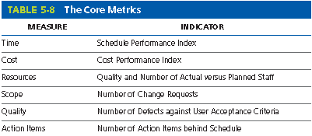

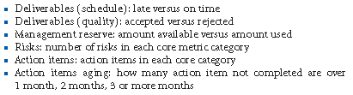

##### Converting Metrics to KPI

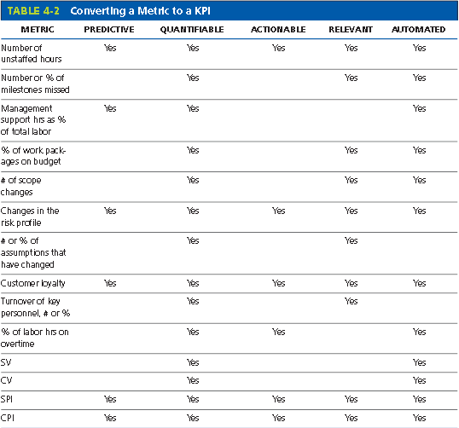

#### Project estimation techniques

##### Estimation during 4 phases

➊Initiation ⇨ **Order-of-Magnitude** (project-level analogous estimates based on similar projects) ➋High-level planning ⇨ **analogous estimates** or ***percentage techniques*** project-level & major deliverable ➌Final project plan ⇨ ***parametric estimates*** or ***bottom-up estimates/*** ***3-point estimates*** (O-optimistic, P-pessimistic, L-likely {O+4L+P/6}) @ confidence level (⇨**reserve analysis**) ➍Weekly status ⇨ weekly ***rolling estimates*** until completion See ***Estimating Effort in WBS context***

###### Parametric estimates

⬩Based on average known (historical) rates: *source lines of code (****SLOC****)*, *function points*, *function-based sizing (****FBS****)* ⬩**ISBSG** International Software Benchmarking Standards Group ⬩**MONTE CARLO**

**•Environmental specifics (UoM Estimations)** ➊Project Management ➋Requirements/Analysis ➌Design & Development Batch (COBOL, SQR, C, etc.), PeopleSoft Objects, App Engine, Integration Broker, Business Interlinks, Component Interface (excl. calling programs), DMS, Message Agent (excl. subscriber or publisher programs, Oracle Triggers, SQL/Script, Workflow, REPORTING, Security -PeopleSoft Objects, XML Publisher ➍System Testing ➎Performance Support ➏Data Delivery (New Data Set, Enhancements, Definitions) ➐Data Administration ➑Practice Moves ➒Infrastructure ➓Security Activities **11** Third Party Products & Interfaces

##### Monitoring and Measuring Effort

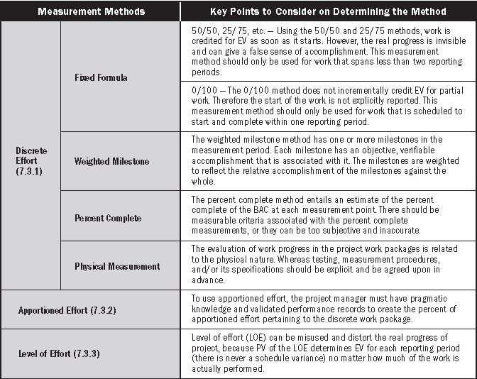

##### Estimating Effort in WBS context

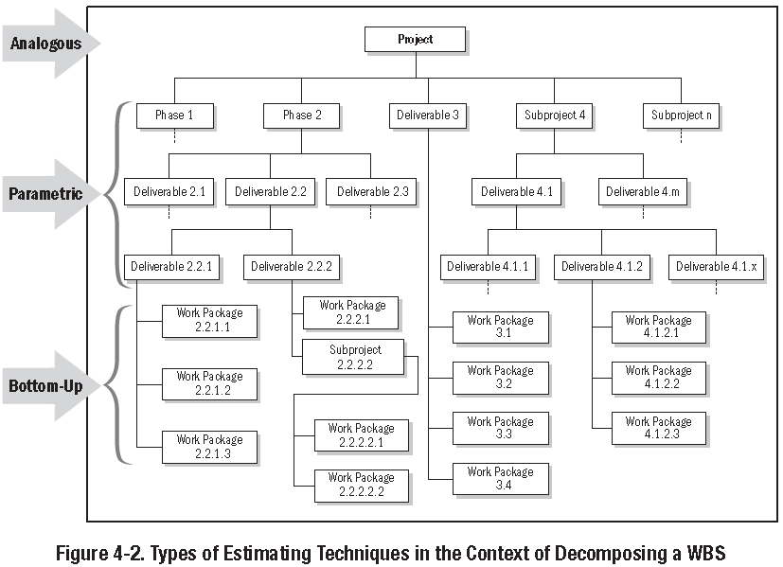

##### 5 groupings for Size scoring

➊Base score (finance, customer, system) ➋Project size ➌Technical complexity ➍Project complexity ➎Project impact

|  |  |
| --- | --- |
| ➊**Base Score**  **A Financial** Total dollar value of customer account balances on system? Worst-case if erroneous financial results? System rating in comparison to others? (Occasional use, high volumes) Average value of each transaction? **B Customer** Customer response if system was? Sensitivity of the data in the system? Importance of the customer base of this system to the bank? Customers interface to this system? **C System** category by Senior Management and Business Owners? Who is the primary user of the system? What is the required system availability? If this system becomes inoperable, how is bank staff affected? System size in relation to other bank systems (Lines of Code/Function Points)?  ➋**Project size**  What size is the project team?  How big is this deliverable (either in terms of LOC or new functionality)?  How will deliverable affect business areas? | ➌**Technical complexity**  How close does the development (not QA) environment resemble production?  How many new interfaces?  What is the nature of the new technological infrastructure to be used?  What is the nature of the new functionality being delivered?  ➍**Project complexity**  Where will development take place?  How much do we know about vendor(s)?  How are requirements being developed?  What level of expertise of the project team?  What type of change management/version control is being used?  ➎**Project impact**  How would a delay in implementing this project affect other projects?  How will this system be implemented?  What fallback plans are in place in the event of system failure? |

##### Estimation Refinement (NASA)

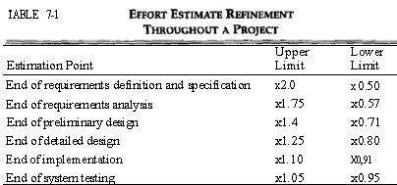

###### Percentages of effort by Software Class

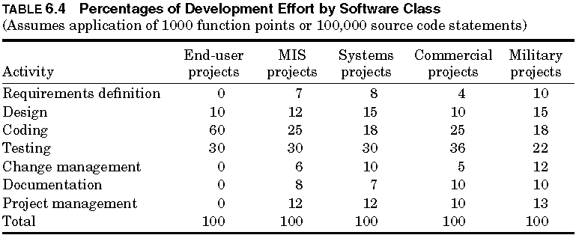

###### Dimensions of Project Complexity

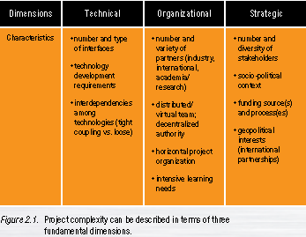

##### Characteristics of Credible estimates

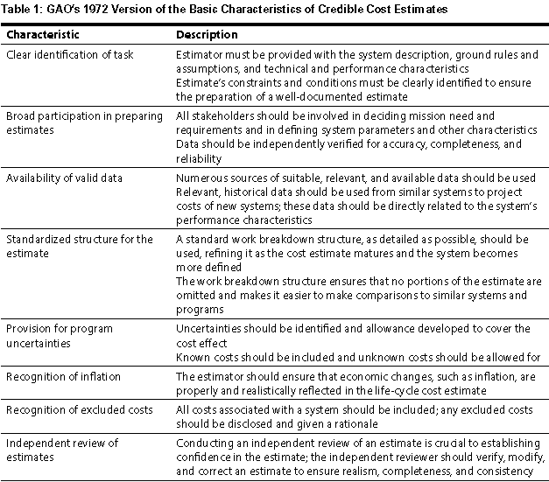

#### My expertise in tracking and reporting project financials

CIBC RSI (2009-10): created budget of $80 million, weekly coordinated the report of 100+ contractors, IT Infrastructure and vendors, weekly reconciled against Accounting, monthly reported financial spending against project progress and milestones achievement

##### Project accounting Time accounting categories

***Major time accounting categories*** ⬩Management (plan, manage stakeholder, manage change) ⬩Administration ⬩Process development ⬩Requirements development ⬩Detailed analysis ⬩Prototyping ⬩Architecture ⬩Detailed Design ⬩Unit Testing ⬩System Testing ⬩User acceptance testing ⬩Deployment

##### How I mapped the project financials against the project deliverables

Regularly discussed with managers of project streams on achievement during reporting period with focus on whether those achievements are accurately reflected in project spending (allowed managers flexibility to sometimes early start low-hanging fruits)

#### Earned Value

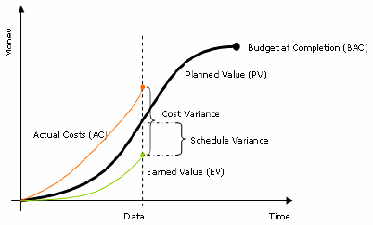

##### Variance

• **Cost Variance (CV) = EV – AC**

• **Schedule Variance (SV) = EV – PV**

##### EVM in summary

###### EVM Performance Measures

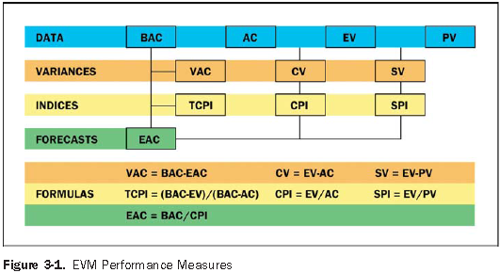

###### EVM and basic PM questions

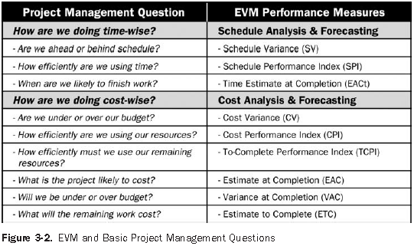

###### EVM performance measures interpretation

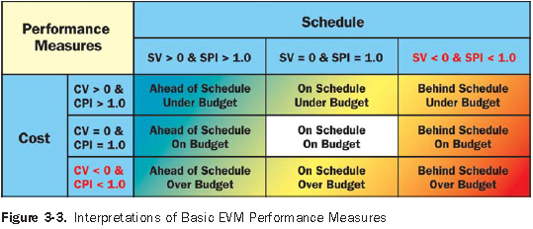

##### Normalized performance indices

• **Cost Performance Index (CPI) = EV / AC** (value < 1.0 indicates a cost overrun compared to the budget estimates; interpreted as “I am getting x cents out of every $”. This indicator can be used to forecast project costs at completion.

• **Schedule Performance Index (SPI) = EV / PV** - Interpreted as “I am progressing at y% of the rate originally planned”. This index is not a reflection of the schedule on its own, and should be reviewed in conjunction with the project plan to determine true project position

##### Forecast cost and/or schedule completion

• **Estimate at Completion (EAC) = AC + ((BAC - EV) / CPI),** **BAC** = total PV @ completion

• **Estimate to Completion (ETC) = (BAC - EV) / CPI -** revised work schedule completion

##### Earned Schedule

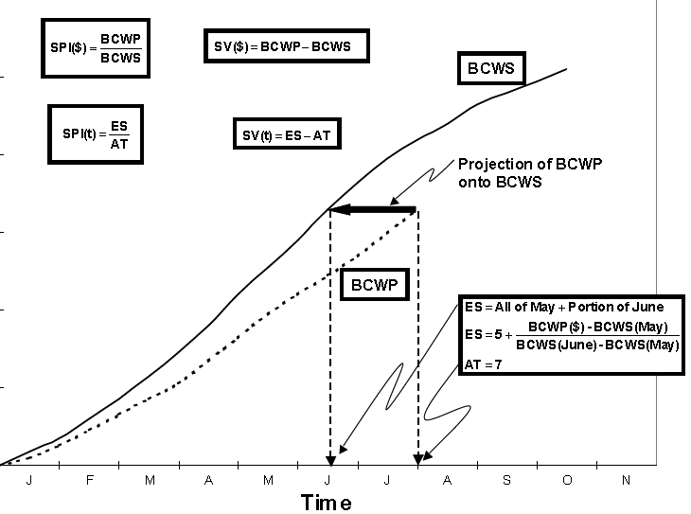

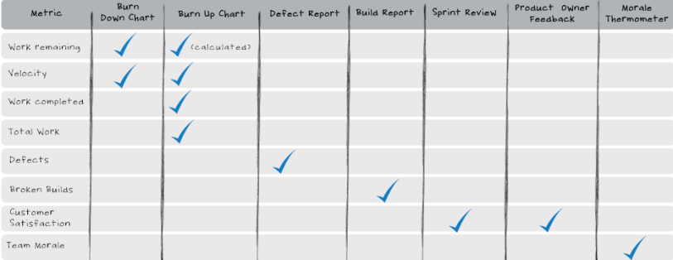

##### Variance Analysis Report

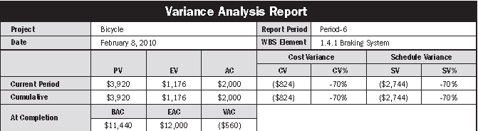

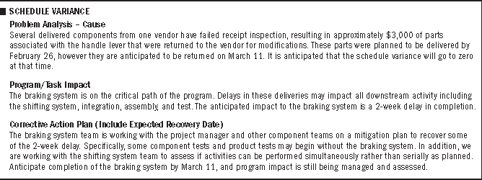

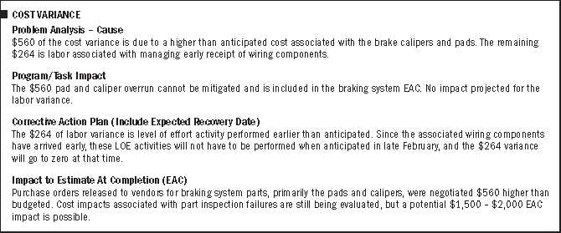

🕮**AGILE Planning****,** **Budgeting****,** **Charting**

## Project Processes and Tools

#### Recourse planning and Cost Management

|  |  |  |  |  |
| --- | --- | --- | --- | --- |
|  | **Recourse Planning** | **Cost Estimating** | **Cost Budgeting** | **Cost Control** |
| **Information**  **needed** | ⬩Work breakdown  structure  ⬩Historical info  ⬩Scope statement  ⬩Recourse pool  description  ⬩Organizational  policies | ⬩Work breakdown  structure  ⬩Recourse rqrmts  ⬩Recourse rates  ⬩Activity duration estimates  ⬩Historical info  ⬩Chart of accounts | ⬩Cost estimates  ⬩Work breakdown  structure  ⬩Project schedule | ⬩Cost baseline  ⬩Performance rprts  ⬩Change requests  ⬩Cost management  plan |
| **Tools**  **and**  **Techniques** | ⬩Expert judgment  ⬩Alternatives  identification | ⬩Analogous estimating  ⬩Parametric modeling  ⬩Bottom-up estimating  ⬩Comp, tools | ⬩Cost  estimating  tools and  techniques | ⬩Cost change  Control system  ⬩Performance  measurement  ⬩Additional planning  ⬩Computerized tools |
| **Results -**  **Profits** | ⬩Recourse requirement | ⬩Cost estimates  ⬩Supporting detail  ⬩Cost management plan | ⬩Cost baseline | ⬩Revised cost estimates  ⬩Budget updates  ⬩Corrective action  ⬩Estimate at completion  ⬩Lessons learned |

#### Activities and Scheduling

|  |  |  |  |  |  |
| --- | --- | --- | --- | --- | --- |
|  | **Activity**  **Definition** | **Activity**  **Sequencing** | **Activity**  **Duration**  **Estimating** | **Schedule**  **Development** | **Schedule Control** |
| **Information**  **needed** | ⬩Work breakdown structure  ⬩Scope statement  ⬩Historical information  ⬩Constraints  ⬩Assumptions | ⬩Activity list  ⬩Product Desc  ⬩Mandatory dependencies  ⬩Discretionary  dependencies  ⬩External dependencies  ⬩Constraints  ⬩Assumptions | ⬩Activity list  ⬩Constraints  ⬩Assumptions  ⬩Recourse requirements  ⬩Recourse  capabilities  ⬩Historical  information | ⬩Project network diagram  ⬩Activity duration  estimates  ⬩Recourse  requirements  ⬩Recourse  Pool description  ⬩Calendars  ⬩Constraints  ⬩Assumptions  ⬩Leads and  Lags | ⬩Project  schedule  ⬩Performance Reports  ⬩Change  requests  ⬩Schedule  management  plan |
| **Tools**  **and**  **Technique** | ⬩Decomposition  ⬩Templates | ⬩Precedence  diagramming method (PDM)  ⬩Arrow  Diagramming method (ADM)  ⬩Conditional  diagramming methods  ⬩Network  templates | ⬩Expert judgment  ⬩Analogous  estimating  ⬩Simulation | ⬩Mathematical analysis  ⬩Duration  compression  ⬩Simulation  ⬩Recourse  leveling  heuristics  ⬩Project  management  software | ⬩Schedule  Change control  system  ⬩Performance  measurement  ⬩Additional  planning  ⬩Project  management  software |
| **Results -**  **Profits** | ⬩Activity list  ⬩Supporting detail  ⬩Work breakdown  Structure updates | ⬩Project  network  diagram  ⬩Activity  list updates | ⬩Activity  duration  estimates  ⬩Basis of  estimates  ⬩Activity list  updates | ⬩Project  schedule  ⬩Supporting  detail  ⬩Schedule  management  plan  ⬩Recourse  requirement  updates | ⬩Schedule  updates  ⬩Corrective  action  ⬩Lessons learned |

## CIBC Enterprise Delivery framework EDF

#### Gating processes

##### Gate reviews (for application projects)

**Gate 1:** Design Complete, Ready for Construction/Build

**Gate 2:** Application Code Complete, Ready for UAT Testing

**Gate 3P**: UAT Testing Complete, Application Ready for Production Testing

**Gate 3 Final:** Ready for Production

##### Infrastructure Gate

**Gate i1**: Design Complete, Ready for Infrastructure Build

**Gate i2**: Infrastructure Build Complete, Ready for Testing

**Gate i3**: Testing Complete, Ready to Receive Application

##### Gate review meeting

(1.5 hour, 6 weeks notice) - Gate Review Meeting’s attendees

➊Project Team Representatives (Project Manager, Project Team Subject Matter Experts -application development resources, application architect, database, user interface, testing/quality assurance) ➋Gate Chair(s) ➌Technology Infrastructure & Technology Solutions ➍Enterprise Internet Security (EIS) who reviewed **Threat/Risk Assessment (TRA**) ➎Operations - *For HP HA*: HP Architecture, HP Operations, HP Project Manager. For *Shared Infrastructure*, this includes appropriate GCO/GCC/PAS representation

#### 11 Control groups

➊**Action Items Tracking** ⬩Action Items Log ➋**Application Retirement Tracking** ⬩Application Retirement Checklist ➌**Change Control** ⬩Change Control Log ⬩Change Request Form ➍**Document Review & Approval** ⬩Walkthrough approval ⬩Walkthrough notice ➎**EPM Update** EPM Project Schedule ➏**Health Check Update** ⬩Health Check Status Report ➐**Issue Tracking** ⬩Issue Log ➑**Project Reporting Facility PRF Update** ➒**PCM Risk Mitigation** ⬩Stakeholder Role Map ⬩Organization Readiness Assessment ⬩Change Planning Worksheet ⬩Polarity Analysis & Mapping Templates ➓**Progress Reporting** ⬩Progress Report 🞧 **Risk Tracking** ⬩Risk Log

#### EDF Phases and Responsibilities (v6)

##### Phase 0 – Pending (Business Initiation)

|  |  |
| --- | --- |
| •Business Processes •Business Proposal •High-level requirements | BA/Project sponsor |
| •TO Intake Request Form •Unified Triage/ PPM create opportunity | Project lead |

##### Phase 1.1 – Planning Initiation & Requirements

|  |  |
| --- | --- |
| •Business Current/Future state FMEA[1] •Voice of the customer •Gap Analysis | BA |
| •Business Case – Request for Seed | Project sponsor |
| •Project charter •Kick-off document •Work package Template •Team List •Development Plan •Timeline •Risk Assessment •Communication Plan •Status Meeting Minutes •Issue Log | Project lead |
| •Benefits Realization Plan (start) | Project sponsor, Project lead |
| •Detailed requirements | BA/Project lead |
| •GSSP Goods & Services Sourcing Req. | Project lead |
| •Candidate architecture •TO Intake •Unified Triage (A) | TO lead |

##### Phase 1.2 – Planning Design

|  |  |
| --- | --- |
| •Business Planning (Communication, Training, Pilot)  •GOI Business Gating | Project lead/Business lead |
| •Business Case approval •GSSP Contract approval  •NIAP – NIRA •Project reporting facility PRF setup | Project lead/Business lead |
| •Application Design •CETM Test Planning, TEP (Test Execution Plan) •Change Request Log  **Gate 1** | Project Lead, Development Lead, QA Lead |

##### Phase 2.1 – Execution Construction

|  |  |
| --- | --- |
| •Business Planning (Implementation) •CETM DIT, Unit Testing •Service Continuity ADRP/ ACRP | Project lead/Business lead |

##### Phase 2.2 – Execution Testing

|  |  |
| --- | --- |
| •CETM DIT, Unit Testing **Gate 2, Gate 3P** |  |

##### Phase 2.3 – Execution Implementation

|  |  |
| --- | --- |
| •GOI Business Gating •NIAP - NILA  **Gate 3F** |  |

##### Phase 3 – Closing

|  |  |
| --- | --- |
| •Project Closure Report •Post Implementation Review (PIR) •PSAT •Benefits Realization Plan (execute) |  |

🕮**RSI and EDF Mapping** 🕮**PPM and Triage** 🕮**Application testing** 🕮**AGILE Testing**

🕮**D4 SDLC**🕮**PLANVIEW**

#### EDF Mandatory Test Processes

##### Test Phases, Levels and Types

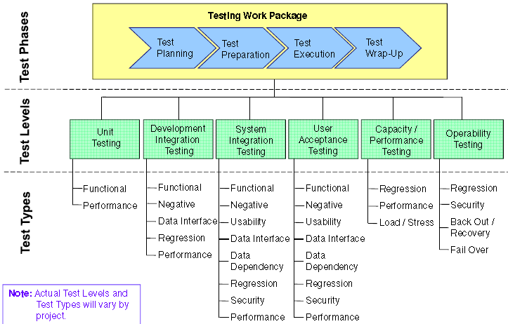

##### Considerations for mandatory test processes

|  |  |
| --- | --- |
| **Mandatory Test Process** | **Considerations** |
| **Determine Test Environment**  **Requirements** | If test and production environment differ •Identify risks & mitigation strategies •Document in Test Plan |
| **Establish Entry and Exit Criteria** | •MUST document exit criteria for DIT •MUST document entry and exit criteria for all other test levels (except Unit) |
| **Create a Traceability matrix** | •Demonstrates test coverage •MUST be created for UAT |
| **Construct Test Cases** | •MUST be documented for UAT •MUST be documented for SIT |
| **Perform Test Execution** | •Results MUST be documented (except for Unit test level)  •Test Level Completion Report MUST be created for UAT and signed off •Test Level Completion Report MUST be created for SIT and Capacity & Performance testing |
| **Perform Variance Management** | •All variances found in all Test Levels (except Unit) MUST be logged •Severity levels MUST be consistent across all test levels that will be conducted for a planned change |
| **Obtain Management Approvals** | •At minimum, business & technology management sign off  MUST be obtained for the UAT Plan and UAT Test Level Completion Report •Open variances at completion of UAT MUST be documented in UAT Test Level Completion Report •Number of tests executed •Number of tests planned not executed & reasons why •Recommendation to proceed or not to next level |
| **Wrap Up Test Work Package** | •MUST create a paper and/or electronic testing project file for all test documentation •All sign-offs (including e-Mail sign-offs) MUST be filed with the rest of the test documentation |

CEMLI **=** Configuration/ customization, Extension, Modification, Localization, Internationalization

##### Test Processes

⬩Assess Risks ⬩Perform Test Planning ⬩Determine Test Levels ⬩Determine Test Types ⬩Determine Test Data Requirements ⬩Determine Test Environment Requirements ⬩Establish Entry & Exit Criteria ⬩Create Traceability matrix ⬩Construct Test Specifications ⬩Perform Test Execution ⬩Perform Variance Management ⬩Capture Test Metrics ⬩Obtain Management Approvals ⬩Wrap Up Test Work Package

##### Testing Risk Assessment

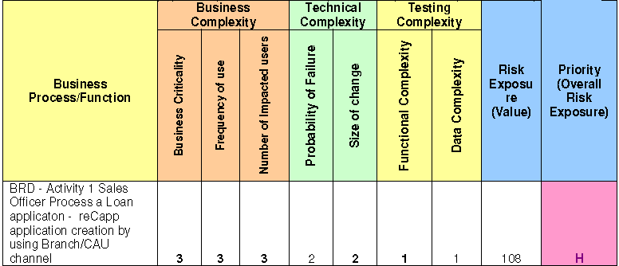

## Incremental Commitment Methodology

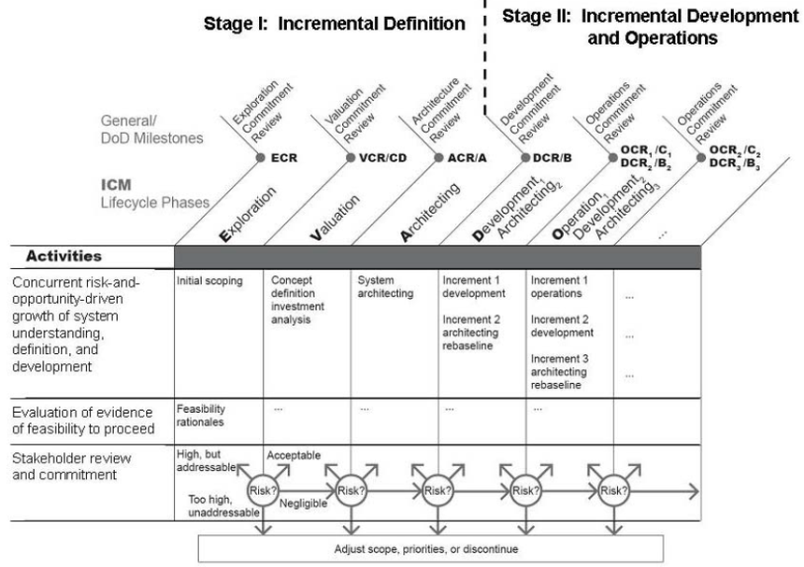

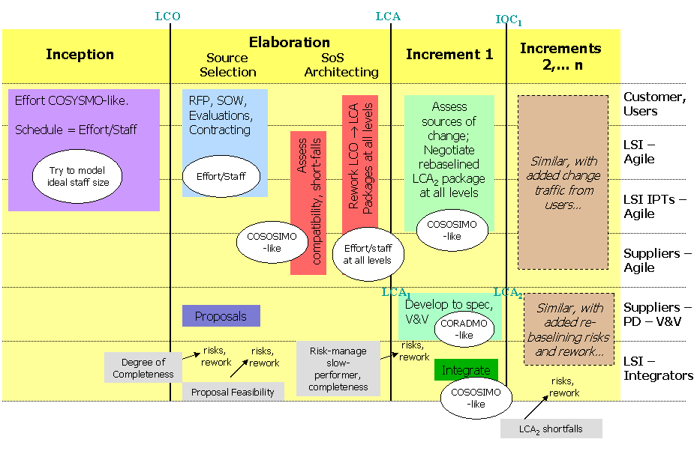

## Microsoft Dynamics SURE STEP Methodology

|  |  |
| --- | --- |
| **Phase** | **Tasks during phase** |
| **Diagnostic** | * Evaluate client business processes and infrastructure * Due diligence: ascertain requirements and fit with solution, assess resources * Prepare project plan, proposal and **Statement of Work** |
| **Analysis** | * Analyze current business model and finalize **Functional Requirements** * Finalize **fit-gap analysis** * Develop **Environment Specification** |
| **Design** | * Develop **Functional Design, Technical Design, Solution Design** * Finalize data migration design * Establish test criteria |
| **Development** | * Finalize configurations, set up standard solution * Develop, finalize custom code * Conduct functional and feature test * Create **User Training** |
| **Deployment** | * Set up production environment * Migrate data to production * Conduct user acceptance * Train users and finalize user documentation * Conduct go-live check and promote system to production |
| **Operation** | * Resolve pending issue * Finalize user documentation and knowledge transfer * Conduct project post-mortem * Provide on-going support |
| **Optimization** | * Leverage Review Offerings to determine whether the solution has been optimized * Analyze the system to determine how it can be optimized |
| **Upgrade** | * Assess customer’s current business processes and solution * Document the requirements for new functionality * Upgrade to the new release, add new functionality, promote existing customizations, eliminate codes no longer required |

##### Microsoft Dynamics SURE STEP Analysis

###### Activities

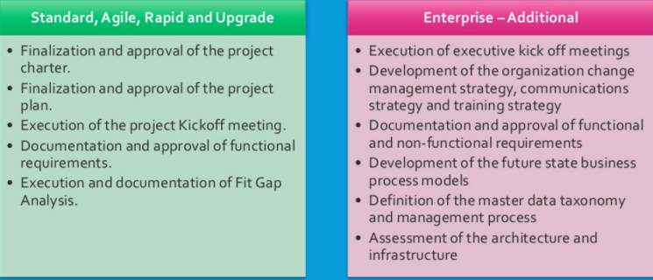

###### Deliverables

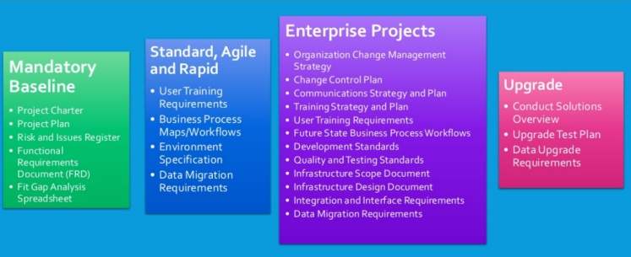

###### Milestones

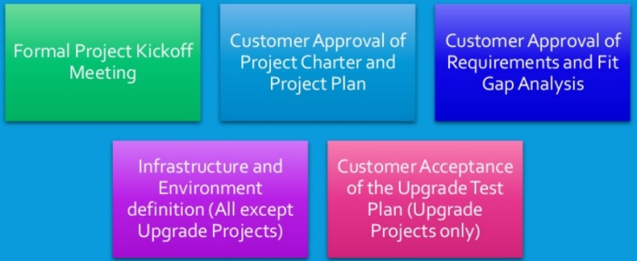

##### Microsoft Dynamics SURE STEP Design

###### Activities

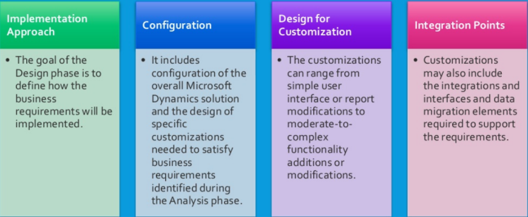

###### Deliverables

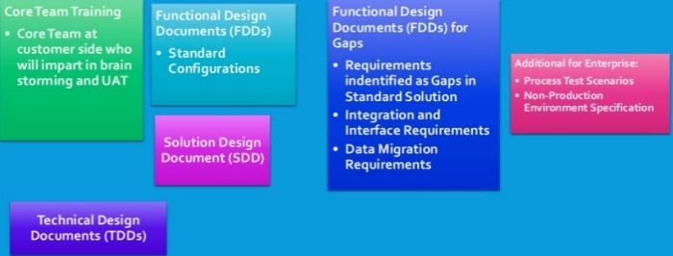

###### Milestones

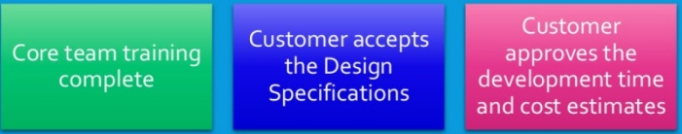

##### Microsoft Dynamics SURE STEP Development

###### Activities

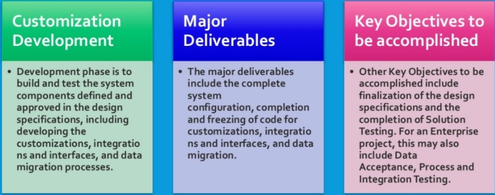

###### Deliverables

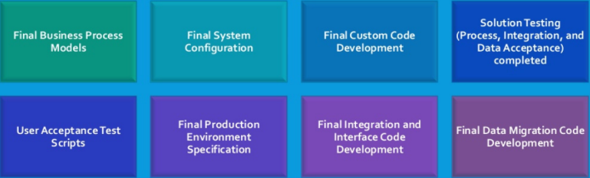

###### Milestones

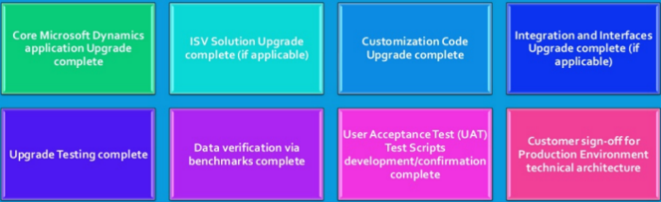

##### Microsoft Dynamics SURE STEP Deployment

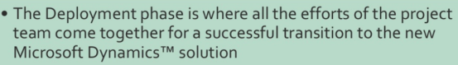

###### Deliverables

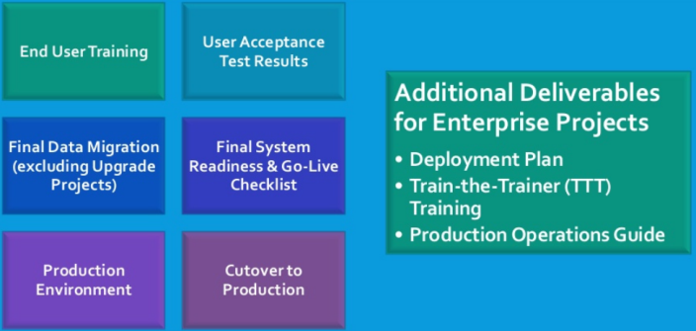

###### Milestones

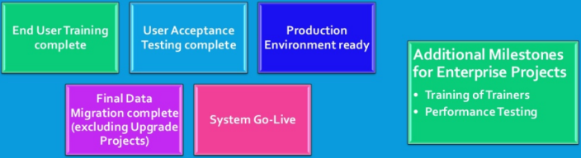

##### SURE STEP Operations

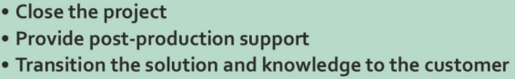

###### Deliverables

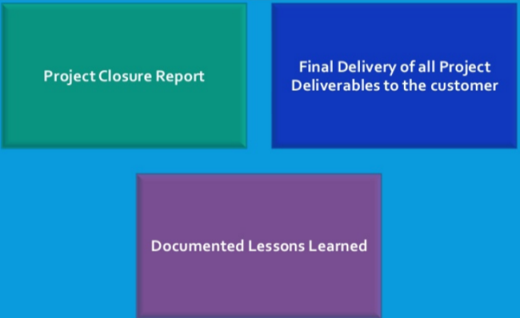

###### Milestones

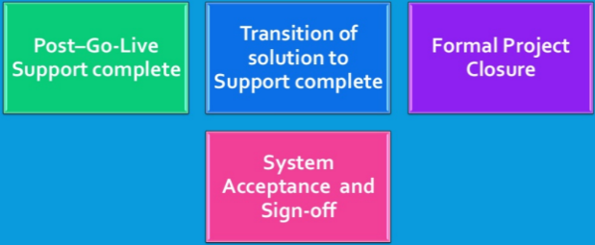

##### Microsoft Dynamics SURE STEP AGILE

## PERT, CPM, GERT

##### Definition

**PERT (Program Evaluation and Review Technique)** – when *uncertain* activity times - 3 time-estimates Expected Time = (Best + 4 Most likely + Pessimistic)/6 - Activity slack max length of time that activity can be delayed without delaying project

**CPM (Critical Path Method)** - when *certain* activity times

**GERT (Graphic Evaluation and Review Technique)** Used only in complex projects • Overcomes PERT & CPM limitations (complex to set up relationships, biasedtime estimates, overlooked near critical paths) • Allows completed/not completed (succeed/ fail) individual activity • Allows looping back (redoing activity) or skipping

##### Critical Path, ES, EF, LS, LF

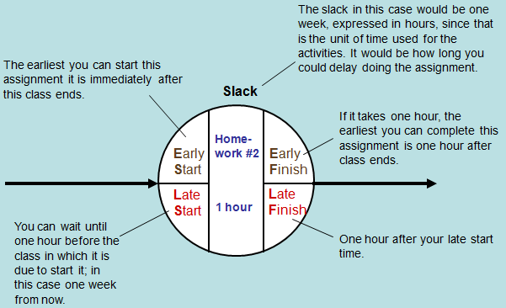

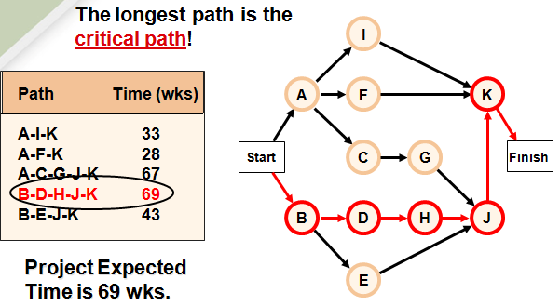

##### Critical Path Method (CPM)

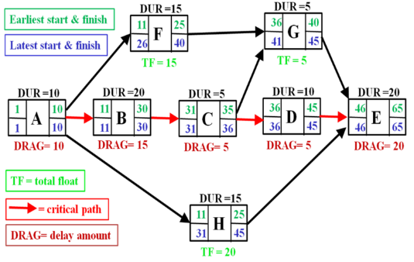

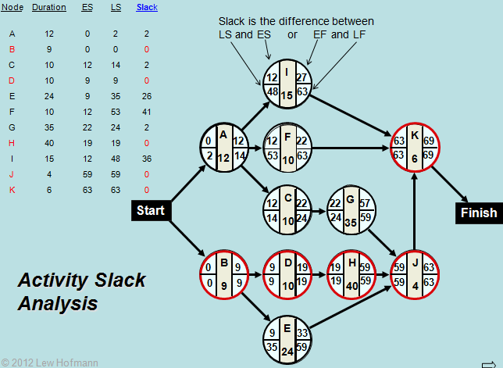

##### MS Project



## MS Project

#### MS Project schedules

🞟Plan ahead the key phases before creating the project plan in MS Project 🞟Use PMI-compliant templates for a quick start 🞟Define “**Phases**”, “**Tasks**” and “**Milestones**” by alternatively using manual and automatic scheduling 🞟***Progressive elaboration***, ***rolling-wave*** *planning* 🞟Use the ***WBS Coding tool*** to track changes 🞟Conduct **What-if** Scenarios with **Multilevel Undo** 🞟Set **project baseline** to track variances 🞟**EVM**. Set baseline, preconfigured *Earned-Value-Over-Time-Report* - **Planned Value PV** (**Budgeted cost of Work scheduled-BCWS**), **Earned Value EV** (**Budgeted cost of Work performed-BCWP**), **Actual Cost AC** (**Actual Cost of Work performed-ACWP**), **Schedule Variance SV=EV-PV**, **Cost Variance CV=EV-AC**, EAC, BAC, VAC – Earned Value Cost Indicators CV%, **Cost Performance Index CPI=EV/AC**, TCIP – Earned Value Schedule Indicators SV%, **Schedule Performance Index SPI=EV/PV**

#### MS Project 7 steps to Build Realistic Schedule

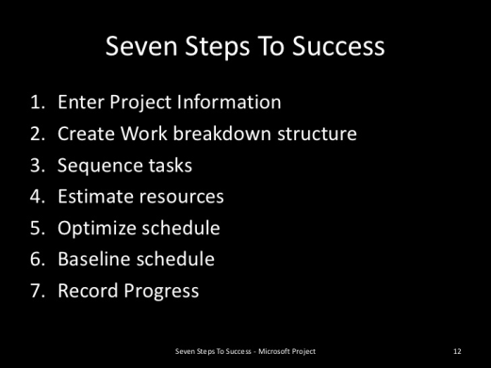

##### Step 1 Enter project information

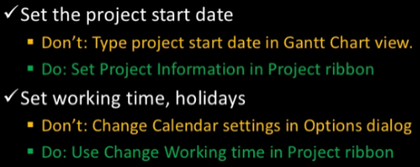

##### Step 2 Create WBS

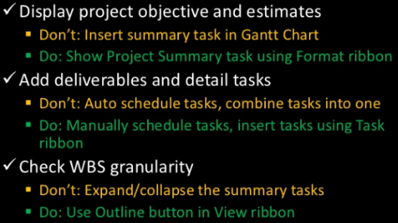

##### Step 3 Sequence tasks

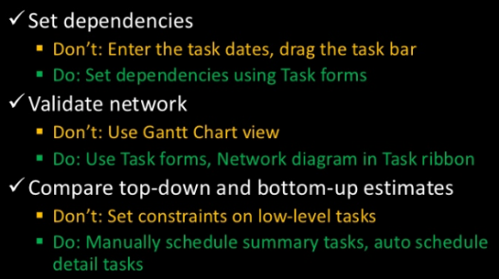

##### Step 4 Estimate resources

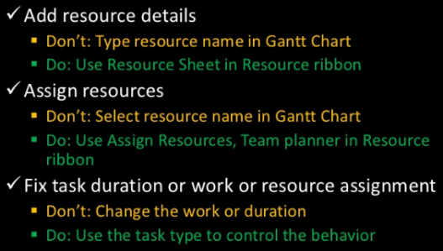

##### Step 5 Optimize schedule

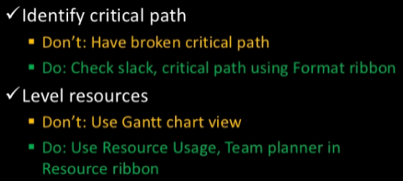

##### Step 6 Baseline schedule

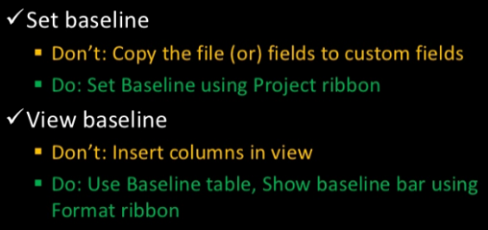

##### Step 7 Record progress

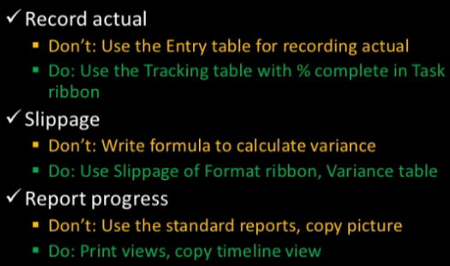

#### MS Project Schedule Checklist

Notes: **summary task** = task with indented subtasks @ lower level in WBS - **detail task** = task without indented subtasks listed beneath it. Checklist categories:

Work Breakdown Structure (WBS), 86

Estimates, 87

Dependencies, 87

Scheduling Constraints, 87

Resources, 87

Assignments, 88

Optimizing, 88

Reporting, 88

Updating, 88

##### General

•Objective of final product of project (if not described in File, Properties, Comments)?

•Deadline date of project (if not shown as a deadline date in the schedule)?

•Cost budget? If yes, how much?

•Person hour budget (effort)? (person hours/ days/ weeks/ months/ years)?

•Work time estimates pure or gross?

•Rolling Wave approach in planning? Duration of detail planning window?

•Will you do task updates (durations) or assignment updates (time sheets) or both?

##### Setup

•Does **File, Properties, tab General, Comments** field describe the objective or final product of the project? Description is visible as **Note** on project summary task.

•Do the working hours on the **Tools, Change Working Time, Standard** (Project Calendar) correspond to the **Tools, Options, Schedule, Hours per day** setting? Are working times 8AM-12PM and 1PM-5PM consistent with 8 hours/day and 40 hours/week. Quickest way to check consistency: choose **Tools, Change Working Time** to take directly to the **Tools, Options, Calendar** dialog.

##### WBS

•Is WBS a deliverable-oriented breakdown structure? Are there deliverables in the WBS? Deliverables captured using nouns (perhaps with adjectives, but without verbs). Verbs change deliverable into activity. If no nouns in WBS, there are no deliverables. Alternatives for a deliverable-oriented breakdown: phase-oriented breakdown or an organizational breakdown. From a project control perspective, these are less effective.

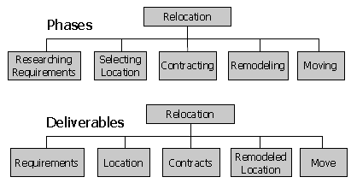

Large projects: breakdown level 1 = phases, broken down into deliverables on level 2

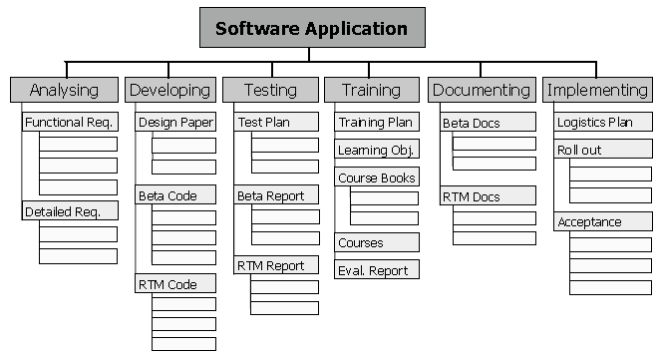

###### Is the list of deliverables complete?

•Are all expected deliverables explicitly included in the WBS? This should include the significant reporting items (e.g. monthly reports, test reports).

•Are out-of-scope deliverables explicitly excluded from the WBS? We recommend you capture exclusions in **File, Properties**, tab **General, Comments** field.

•There are no unnecessary deliverables in the WBS.

•Include the project management deliverables and activities in the WBS. Enter overhead tasks (ongoing tasks during entire project, e.g. project management, technical support and quality control) as ***long-duration tasks***.

###### Does the WBS have a logical hierarchy?

•If you don’t have a logical hierarchy, you may report the wrong cost and duration by phase or by deliverable. You can check if the WBS is a logical hierarchy by expanding the outline structure level by level by clicking **SHOW** on the **Formatting** toolbar.

•Is the WBS an indented list with multiple, hierarchical levels instead of one long list?

•Are the phases, if present, on a higher level than the deliverables?

•Are the tasks, if present, on a lower level than the deliverables?

•Does each element logically relate to its summary tasks?

•Do the subtasks comprise all the work of their summary task?

•Does each summary task have at least two detail tasks? There should be no duplication of deliverables or overlap between the deliverables.

•Is the feature **Tools**, **Options, View, Project Summary Task** used instead of a physical project summary task? MS Project’s **project summary task** has ID number 0 (zero).

•Are WBS elements properly formulated? **Phases** use imperfect tense (-ing). **Deliverables** use noun (perhaps with an adjective but without verb). **Detail tasks** use present tense verb. **Milestones** use noun of deliverable and verb in past or perfect tense - or words: ‘ready’, ‘complete’ or ‘sign-off’

•Are deliverables name, tasks and milestones used consistently in the entire WBS?

•Are there enough milestones? (roughly 1 milestone for each deliverable). Milestone events center on deliverables when deliverable is completed, approved, sent, signed off, published, or shipped. Check this by applying the standard filter **Milestones** and checking if most deliverables (summary tasks) have a milestone.

###### Does the WBS have the right level of detail?

•Can you estimate the duration or work on the detail tasks?

•Do you have difficulties finding the dependencies between the detail tasks?

•Do you often assign more than one resource per task?

•Are there detail tasks that are longer than a reporting period?

•Detail tasks with durations longer than 10% of the project duration **(1%-10% Rule)**? Check by applying filter 1 IIL Level of Detail > 10% of Proj Dur.

***There may be too many detail levels in the WBS:***

•Do you think there are too many levels, or the task list too long?

•Checklist items or reminders into the task list? Transfer these to the Notes field.

•Can you update all detail tasks in the schedule during project execution?

•Tasks with durations shorter than 1% of project duration (1%-10% Rule)?

•Is the WBS clear to all project stakeholders (customers, suppliers, upper management, team members, and support staff)?

•Do the overhead tasks (like “project management”) extend over the entire project? Do the status meetings, as recurring tasks, continue over the entire duration of the project?

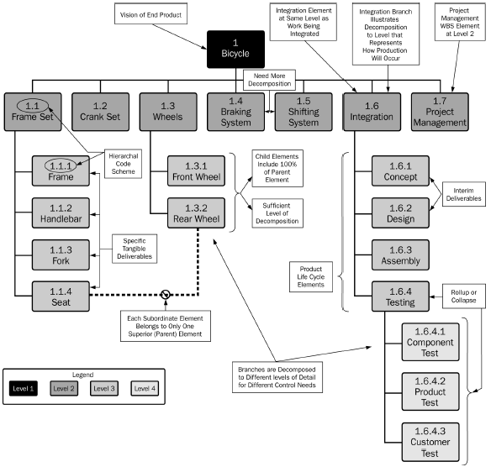

##### Estimates

###### Are estimates reasonable given work that needs to be performed?

•This may be hard to evaluate if you are not a subject matter expert. However, we all know that writing documents takes a long time, particularly if they are formal or contractual documents – See estimation techniques

###### Are estimates consistent with working hours on Standard (Project Calendar)?

•Gross working time estimates should be entered in a schedule with gross working hours (typically 8AM-5PM).

•Pure working time estimates should be entered in a schedule with pure working hours. 100% productive working hours correspond to a shorter working day, for example, 8AM-3PM. You should change the working times to shorter **Non-default** working times on the Standard (Project Calendar) in **Tools, Change Working Time**. If you do this, you should also revise the Hours per day and Hours per week conversion factors in Tools, Options, Calendar accordingly. This is to keep your schedule consistent.

##### Dependencies

###### Dependency type

⬩Finish-to-Start (FS) – default ⬩Finish-to-Finish (FF) – simultaneous end ⬩Start-to-Start (SS) - simultaneous start ⬩Start-to-Finish (SF) - rare

###### Does the logic of the network make sense?

You can check this by showing the highest outline levels only and checking whether the timing of the deliverables (or phases) makes sense on this high level.

###### Is the network of dependencies complete?

The network is complete if the task bars of all detail tasks are tied up at both ends. However, the network can have multiple starting points, but only one ending point. Only then will the **Critical Path calculation** be correct. The following questions will help determine if the network is complete:

•Is the logic as much as possible set on detail tasks only? If dependencies run over summary tasks, it takes time to check if the network is complete. It is also too hard to trace the Critical Path and understand it. Only with a complete network will the schedule be a fully dynamic model of the project. You can check if there are dependencies on summary tasks by applying filter 2 IIL Summary Tasks with Dependencies.

•Are all the starts of the detail tasks and milestones linked to at least one other detail task or milestone? Exceptions: all tasks that can start when the project starts, external delivery milestones (should have a **Start-No-Earlier-Than** date), recurring tasks, and overhead tasks. Verify if all starts are linked by applying filter **3 IIL Detail Tasks** **without Predecessors**. Note that if the project manager used **SS**- or **FF**-dependencies, the filter is not conclusive. You can check if there are tasks with SS- or FF-dependencies by applying **filter 3 IIL Detail Tasks with SS or FF**.

•Are all ends of the detail tasks and milestones linked to at least one other detail task or milestone? Exceptions: project end milestone, recurring tasks and overhead tasks. You can verify if all finish dates are linked up by applying the filter **3 IIL Detail Tasks without Successors**. Note that if the project manager used **SS- or FF-**dependencies, the filter is not conclusive. Check whether there are tasks with SS- or FF-dependencies by applying the filter **3 IIL Detail Tasks with SS or FF**.

•Are there tasks with an unreasonably large amount of Total Slack? Check by descending sort on **Total Slack** and checking whether the tasks with the largest positive slack were expected to have a lot of slack. If not, you have found missing logic.

When a change is entered into the schedule, does it update the rest of the schedule automatically through dependencies? Is the entire schedule still valid? Where the schedule is not valid, a dependency might be missing. If you have to check the entire schedule on every change, you don’t have a dynamic schedule.

###### Are there redundant dependencies making network difficult to understand?

•Are there dependencies that leapfrog each other?

•Are there dependencies that run in parallel on detail and summary tasks? If that is the case, keep the detail task dependencies and remove the summary task dependencies.

•Does the network have circular logic? Circular logic does not make sense because it is not clear which task should be scheduled first. MS Project warns you not to set circular logic within a single schedule.

##### Deadlines and Constraints

###### Is the project deadline modeled in the schedule?

Set as a ***deadline date*** or as *a* ***hard constraint date*** on the project finish milestone

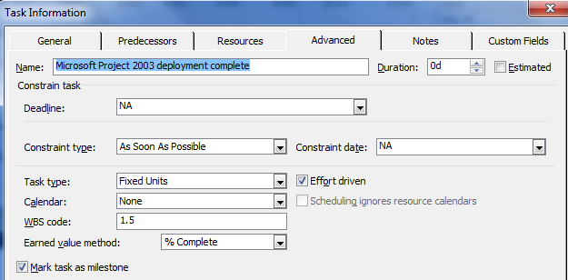

•Does the schedule have the fewest possible schedule constraints? Constraints make the schedule rigid. However, *constraints are allowed on*:

[External dependencies, such as delivery of supplies or arrival of materials

Activities that have to take place on a certain agreed-upon date, like presentations and training. In general, these are activities in which a group of people is involved.

Recurring detail tasks, like status meetings.

Do-or-drop-dead deadlines, like the Dec.31, 1999 deadline for Y2K projects.

Activities affected by (winter) weather conditions i.e., task asphalt streets **starts-no-earlier-than** April 1st.] Display tasks with constraints with filter **4 IIL Constraints other than ASAP** to display recurring detail tasks.

##### Resources

Resources and assignments are important in projects in which it can be expected that limited resource availability or huge workloads will influence the project end date. They are also important if there is a budget and the cost needs to be managed.

###### Are all resources identified in the Resource Sheet?

This is the case if all resources are entered into the Resource Sheet that could have a potential impact on the quality, duration or cost of the project.

**Consolidated Resources** = group of pooled individuals. The maximum units are set to the number of full-time equivalent individuals who are part of the consolidated resource. Full-time equivalency is defined in the **Tools, Options**, tab **Calendar**, **Hours per Day** setting. If you have 2 full-timers and 2 half-timers on a team, the maximum units for that consolidated resource should be set to 2 x 1 + 2 x 0.5 = 3 resources

###### Are there no overlaps between resources or duplication of resources?

If there are overlaps or duplications, the project manager cannot check the workloads of the resources properly. Workloads of one person will be aggregated on two different resource names in the project.

###### Is the availability of the resources appropriately modeled?

This can be assessed by checking:

•Does availability of individuals not exceed 120% (captured in resource field **Max. Units** and availability profile **in Resource Information**, tab **General)**? This threshold was chosen for ***schedule certification*** purposes. It is unreasonable to ask resources for more than 120% availability for periods longer than one week. If the **Max. Units** are less than 100%, is there a valid reason for this? Valid reasons are that the project manager works with pure work time estimates or that the resources have other ongoing work or other projects.

•Are the vacations of individual resources captured on their resource calendars? Vacations are little effort to enter, but their omission can throw projects off track in a major way. You can check this by choosing the report **View, Reports, Assignments…, Who does what,** click **EDIT**, click tab **Details**, select **Calendar**, click **OK**. In print preview, you will now see individual vacations listed under **Exceptions**. You can copy this changed report back into your GLOBAL.MPT using the organizer (**Tools, Organizer**). In this way you have it ready to go for future schedule analysis.

•Are the costs of the resources appropriately modeled?

If the project manager has a cost budget, the costs of the project should be modeled in the schedule. The following guidelines will help determine this:

•Are human resources entered as **Work** resources in the resource field **Type**? Are facilities, machines and materials entered as **Material** resources?

•Do **Material** resources have an appropriate **Material Label** to indicate their unit of measurement?

•Are the rates entered in the appropriate fields?

Time-related costs for **Work** resources in **the Std. Rate** field. Unit-related cost for **Material** resources in the **Std. Rate** field. Time-related cost for facilities and machines as **Material** resources using a combination of the **Std. Rate** field (where you enter the per-unit cost) and the assignment-related **Units** field (where you indicate the number of units used per time unit, for example 1000/day). Use-related costs in the **Cost/use** field. Overtime costs in the **Ovt. Rate** field, but only if the overtime is paid for and at a higher rate than the standard rate; rates that vary over time in the **Cost Rate Tables; m**ultiple rates in the **Cost Rate Tables** and the appropriate cost rate table should be selected for each assignment. Fixed costs in the task-related **Fixed Cost** field.

•Is the cost scheduled appropriately?

•Does the resource-related **Accrue At** field reflect when the cost occurs: at the **Start** or at the **End**, or **Prorated** with the **% Complete**?

•Does task-related **Fixed Cost Accrual** field reflect when the fixed cost will be incurred?

##### Assignments

•Is the **Type** of task appropriate? (**Fixed Duration, Fixed Units** or **Fixed Work**)

•Does each detail task have at least one human resource assigned?

If there are detail tasks without human resources assigned, you have not captured all the workloads in your project. If workloads are missing, the schedule may not forecast finish dates that are feasible. In the **Resource Usage** view there should be no detail tasks listed under the first category **Unassigned**. You can also apply the filter **5 IIL Detail tasks without Resources Assigned**. The filter allows you to easily copy the tasks including their ID-numbers to provide detailed feedback to the project manager. Note that there could still be detail tasks with only material resources assigned if you check the **Unassigned** category or apply the filter. An exception to this rule is that recurring detail tasks do not need resources assigned to them.

##### Optimizing Workloads

•Is the total work within the **person-hour** budget of the project (if a person-hour or person-day budget is available)?

•Are the workloads for the resources reasonable? The workload for individuals should not exceed 150% of their regular availability on a day-by-day basis. The workload should not exceed 120% on a week-by-week basis. These upper bounds may be too high for your own organization. We have arbitrarily set them at these levels to prevent burnout, attrition, and dramatic loss of productivity. These levels are hard cut-off points for most organizations; many will use lower thresholds. The workload of consolidated resources (groups) should not exceed their availability. The workloads should be fairly smooth since there are hidden costs involved with erratic workloads. Note that it is not enough to just check whether there is any red in the **Resource Usage** view. MS Project often highlights more resources red than are truly over-allocated. If there is an over-allocation during only one business hour, the resource will already be colored red. Also, assignments that are already completed are never colored red. Use the **Go To Next Over allocation** on the **Resource Management** to check over-allocations.

##### Optimizing Costs

•Is the total cost within the budget of the project (if a cost budget is available)?

##### Optimizing Time

###### Are the deadline dates and other constraints met in the schedule?

Check this by applying the filter **6 IIL Deadlines or Constraints not met**. The filter displays tasks with a deadline or constraint that have negative slack. When deadline or constraint dates are not met, the schedule may forecast a project end date that is too optimistic.

###### Does the schedule have a Critical Path or a Resource Critical Path?

Check the **Critical Path** by applying the **Tracking Gantt** view. This view has the Critical Path highlighted in red by default. If a schedule has extended when the workloads were leveled, a **Resource Critical Path** needs to be identified. Resource critical tasks need to be marked manually in the field **Marked**. Resource) Critical Path can only consist of detail tasks and milestones and not *level-of-effort tasks* (overhead tasks or recurring tasks) or summary tasks (logic should be kept on the detail tasks).

•Does the (Resource) Critical Path provide a complete explanation for the project duration? You can check the completeness by displaying the (Resource) Critical Path and then looking for gaps in it. Normally, there is at least one critical task on every business day (unless there are lags on critical dependencies). If you find gaps, the (Resource) Critical Path is fragmented and the missing (resource) critical tasks need to be identified.

•Are there as many parallel paths as logically possible in the network of dependencies? Novice schedulers tend to schedule all tasks in one long sequential chain. In that situation there are many soft dependencies that make the duration of the project unnecessary long. When optimizing for time it is important to schedule in parallel what logically can be scheduled to happen simultaneously.

##### Reporting

•Is there a one-page status report available as a View object in your project file that displays the major milestones?

•Are the major milestones filtered in this view instead of grouped together? Many project managers put the major milestones at the top of their schedule to create a one-page overview of the project. This makes the network of dependencies complex in Gantt Chart

•Are the appropriate milestones chosen to represent the status of the project and to forecast the project?

•Does the 1-page view report give an appropriate impression of the project health?

If your schedule has a Resource Critical Path, is there a separate view object that displays the Resource Critical Path?

##### Updating

The following guidelines are mandatory if the project is supposed to be started. A project is supposed to be started if today’s date is later than the project start date.

###### What is the quality of the baseline in the schedule?

•Is a baseline present? A baseline has to be present at project start.

•Is the baseline complete? You can verify the presence and completeness by applying the filter **7 IIL Tasks with missing baseline info**. The filter displays any tasks without entries in **Baseline Start**, **Baseline Finish**, **Baseline Duration** or **Baseline Work**. When assignments are created after the baseline is set, often the Baseline Work field is empty. The filter does not check the field **Baseline Cost**.

•Is the baseline original? The baseline cannot be reset without formal approval of the appropriate project stakeholders.

•Is the baseline relevant? If the project deviated too far from the baseline, a new baseline needs to be negotiated. The baseline should provide a meaningful standard of comparison for the current schedule. You can check this by looking at how far the current schedule bars are removed from the baseline bars.

•Are the appropriate options selected in **Tools, Options, Calculation** for the chosen updating strategy?

⮚For task updating (revising the **Actual Duration** & **Remaining Duration** fields), the options are: Updating task status updates resource status / Split in-progress tasks

⮚For assignment updating (entering numbers from the time sheets into the assignment-related **Actual Work** and **Remaining Work** fields), the options are: **Updating task status updates resource status**. If you keep this option selected, you should not enter % Complete on tasks because this will override time sheet data / Split in-progress tasks

⮚For updating both tasks and assignments, the options are: **Updating task status updates resource status**. Entering a **% Complete** on tasks will override the time sheet information. You cannot enter both types of information unless you de-select this option / Split in-progress tasks

•Is the **Status Date** set to an appropriate date?

The appropriate date is the regular reporting date that is closest to the date of submitting the schedule. Don’t forget to set the **Current date** to the same date as the **Status date** in **Project, Project Information** before updating the schedule.

•Is the schedule up to date as per the **Status date** (or **Current date**)?

•Are all actual durations (actual work / actual hours worked) scheduled in the past? The actuals are scheduled in the past if they are earlier than the status date. Otherwise, the schedule does not reflect up-to-date forecasts. When you bring actual durations to the past, all their dependent tasks may be rescheduled earlier as well, thus updating the forecasts. This is why rescheduling is important.

•Are all remaining durations (remaining work) scheduled in the future? The remaining estimates are scheduled in the future if they are later than the status date. If you leave unfinished work before the status date, you are scheduling work to be done in the past. The work should be moved to the future to update the forecast dates. Otherwise, the schedule does not reflect up-to-date forecasts. If you don’t do this you have created a status report, not a forecast report.

•Are the remaining durations (remaining work) revised? Otherwise, the schedule may not reflect up-to-date forecasts. If the project manager has been revising the durations of detail tasks, these will be displayed. This filter is different from the other filters in the sense that if it displays tasks, it is good. If the filter does not display any tasks, it is an indication that the project manager is not revising (remaining) durations while updating. If remaining durations are not revised, the forecasts are not very accurate, and may not even be reliable

##### MS Project Earned Value

🕮**Earned Value**

**BAC**=Budget at Completion, **BCWS**=Budgeted Cost Work Scheduled, **ACWP**=Actual Cost Work Performed, **BCWP**=Budgeted Cost Work Performed

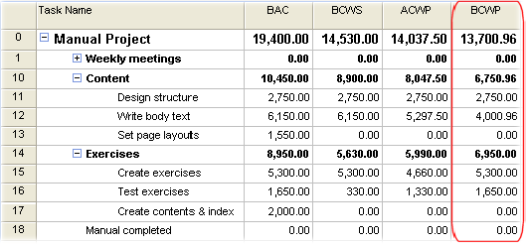

###### MS Project 3 preconfigured views

➊**Earned Value** PV (BCWS), EV (BCWP), AC (ACWP), SV, CV, EAC, BAC, VAC

➋**Earned Value Cost Indicators** CV%, CPI, TCIP

➌**Earned Value Schedule Indicators** SV%, SPI

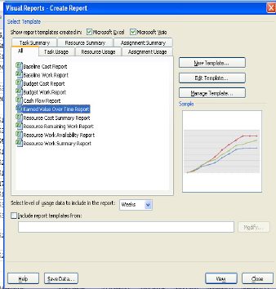

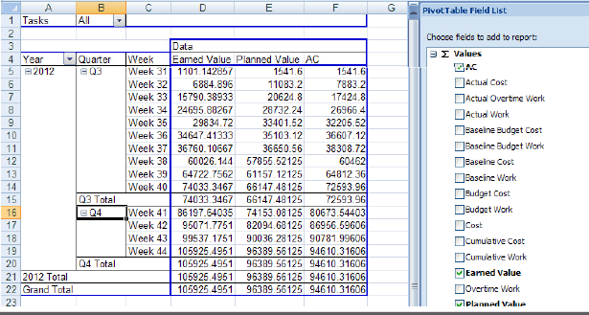

## CIBC PLANVIEW PPM

##### PLANVIEW and EDF

**➊Project Initiation** Completing the Process Steps for Initiating a Delivery Component,

Create a Portfolio, Project Planning (Manager-Portfolio View, Manager-Project View), Review the Work Breakdown Structure (WBS), How to Upload the Project Charter and Key Documents ➋**Project Planning** Refining the Work Breakdown Structure, Determine Durations, Determine Resource Requirements, Reserve Resources to Tasks, Project Funding, Baseline the Project ➌**Project Execution, Monitoring and Control Overview** Monitor Work Completion, Monitor on Target, Update Project Schedule, Update Project Financials, Request Resources, Reporting Project Status, Assign Resources to Work, Risk Management (Enter and Classify a Risk, Monitor Risk Status, Close a Risk) Issue Management (Enter & Classify an Issue, Monitor Issue Status, Reclassify an Issue, Close an Issue) Monitor Changes (Enter/ Classify a Change, Estimate Impact of Change, Update Project Plan, Monitor Change & Review Change Status, Close a Change Request) ➍**Close Project Overview** (Close Project, Change Project’s Status to Completed)

##### Risk Management

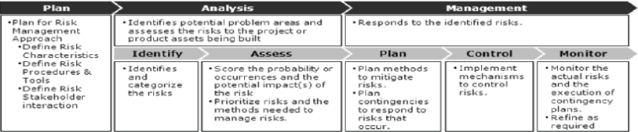

##### Progress report

➊Overall status ➋Finance ➌Schedule ➍Scope ➎Staffing ➏Governance (define and implement processes) ➐QA ➑Sponsor relationship ➒Benefits

##### Status Commentary

➊Overall and commentary on PRF status ➋Upcoming key project activities ➌Latest key achievements

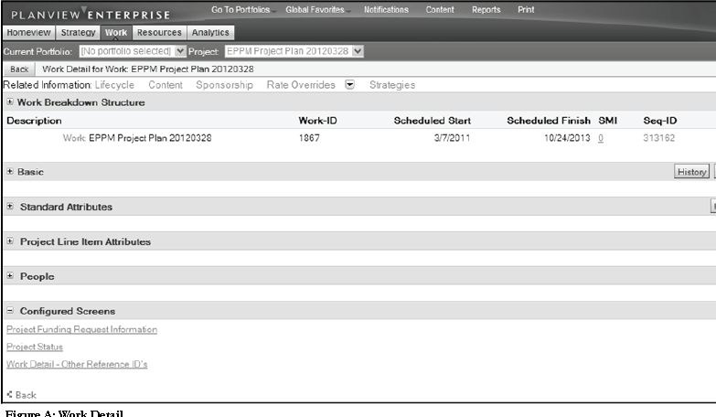

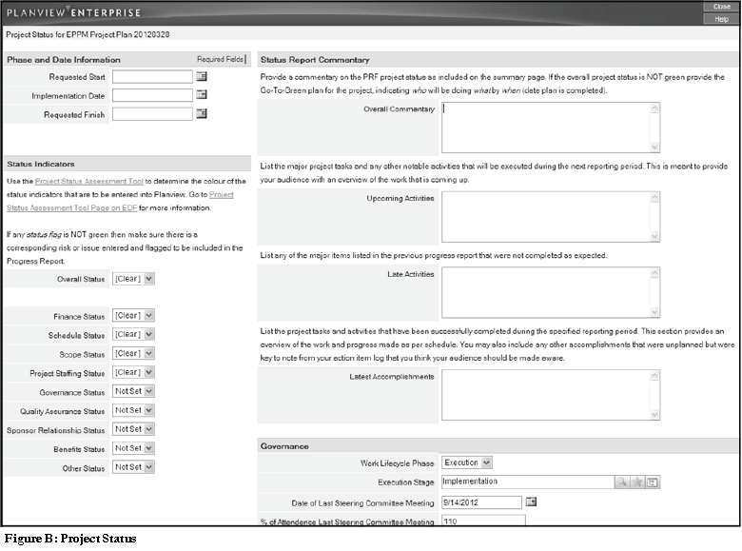

## CA-CLARITY

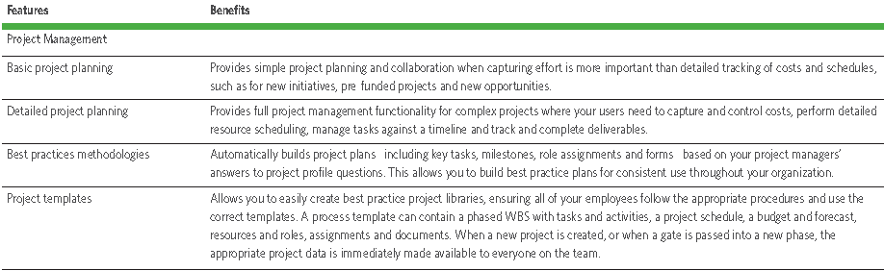

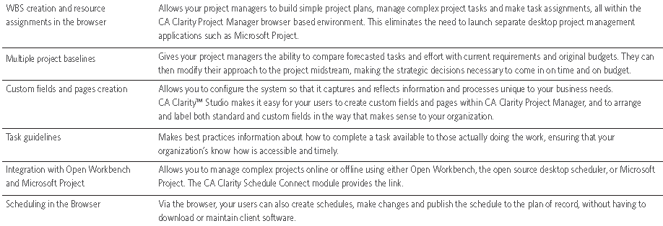

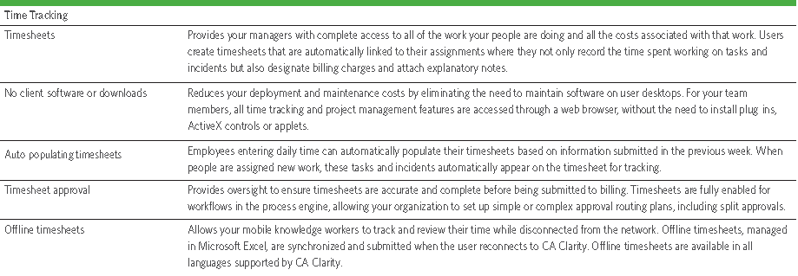

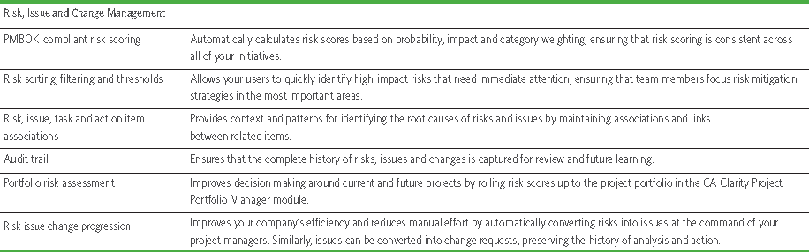

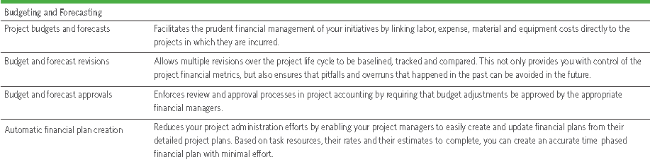

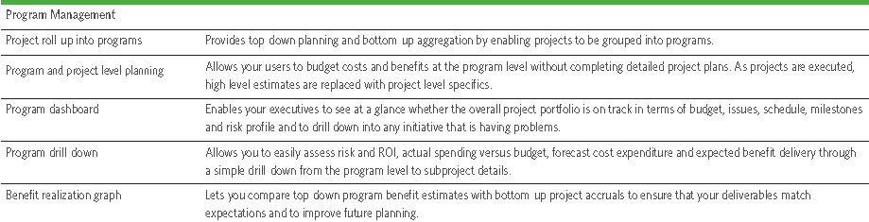

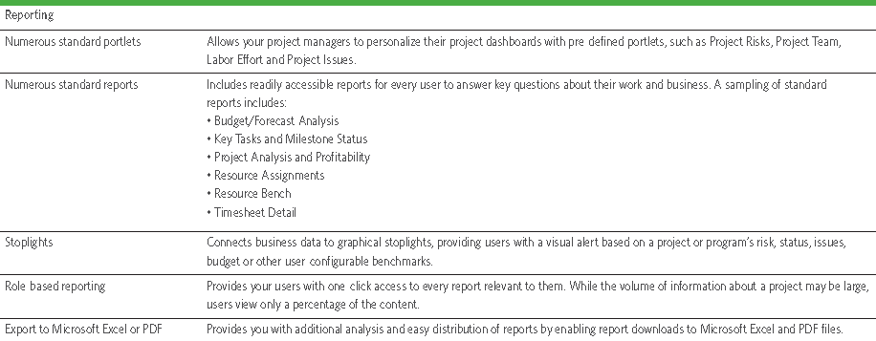

## AGILE

#### Scrum schematics

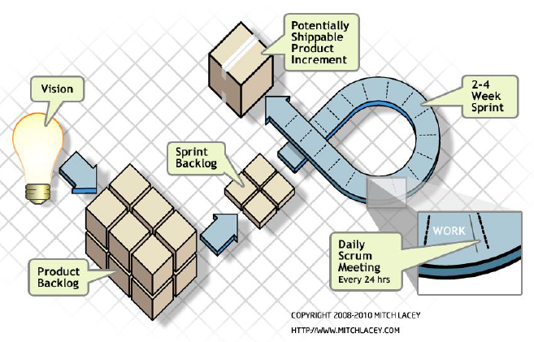

#### Agile Questions

**A-*Biggest challenges starting with Scrum & how can Scrum Master help?*** Un-empowerment because of a) Organizational command and control behavior b) Specific Scrum Master failings 🡪 Scrum Master ❶Eliminate “command and control"; teams run own sprint planning sessions (task estimates/sequencing/assignments, sprint reviews and retrospectives) ❷Control dysfunctional meeting ❸Remove barriers between team members ❹Protect team from stressful outside influences and unnecessary meetings **B-*Most important aspects of Scrum?*** ❶**Product back log** with **stories** ❷Product back log listed by **priority** ❸Stories estimated in **points** ❹**Sprint** created with stories selected for feasibility in sprint time frame ❺**Daily scrums** **C-*Is a Project Manager different from a Scrum Master***? Scrum Master facilitate, coach, provide support/ manager: manage, lead, take responsibility **D-*When is Scrum not a good choice*?** ❶Companies against Scrum ❷Companies expecting lot of benefits from Scrum but cannot commit ❸Companies that matrix numerous people into numerous projects ❹Teams cannot commit to a week of fairly fixed ❺Not software development **E-*4 values in AGILE manifesto***? ❶Individuals & interactions - processes & tools ❷Working software, comprehensive documentation ❸Customer collaboration - contract negotiation ❹Responding to change - following a plan

#### Agile methodologies

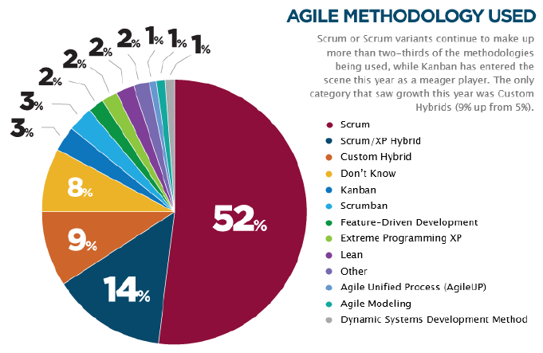

#### Agile Iterative, Incremental, Self Organizing, Emergent

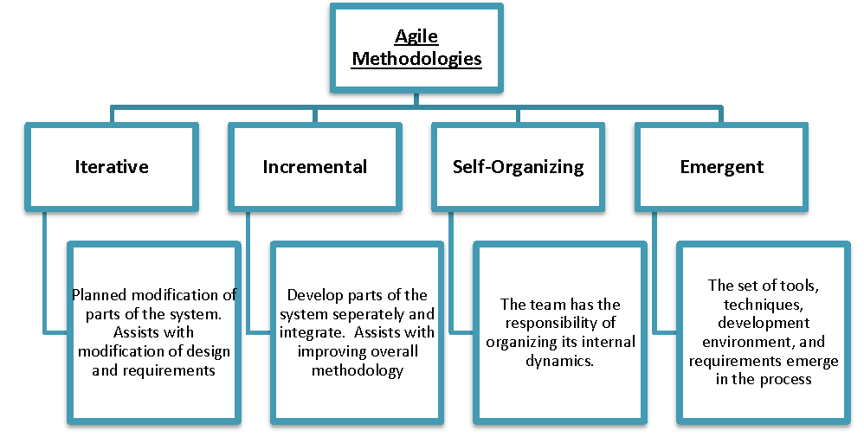

#### Agile at DoD

##### DoD Acquisition Process

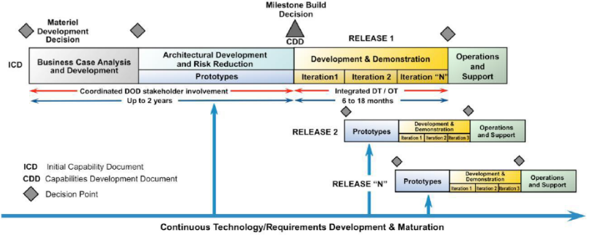

##### Adapted Agile

➊Split project in way that’s closer to spiral development effort than pure Scrum Agile ➋Spiral = 6 months of work (requirement analysis, critical design, development, contractor testing, government testing and information assurance) ➌Partially completed products sent back to customer for review every 3 months to ensure effort aligned with expectations ➍Complete documentation for new capabilities developed per spiral

##### Aligned Agile Document generation

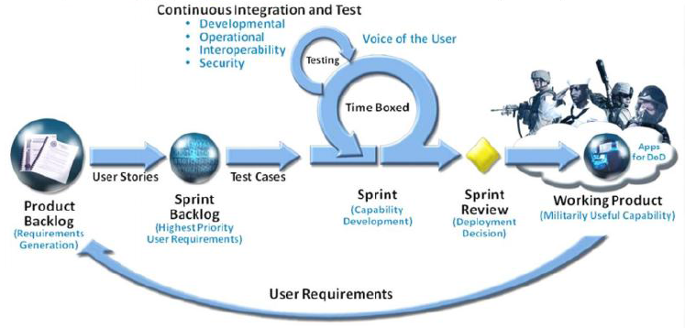

➊Systems Engineering Documents generated during sprint ➋Requirements from capabilities documents and user stories ➌Requirements after sprint ➍Continual integration and testing

##### Scrum Agile Document Development Framework

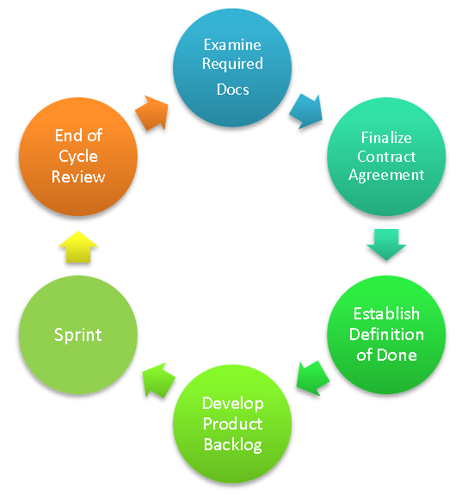

#### Agile PMI-ACP

##### Agile elements

**XP core values** ❶Simplicity ❷Communication ➌Feedback **XP core practices** ❶Whole team ❷Planning games ➌Small releases **Scrum pillars** ❶Transparency ❷Inspection ➌Adaptation **Scrum backlogs** ❶Product backlog ❷Sprint backlog

###### Scrum inspection & adaptation

❶Sprint retrospective ➌Daily scrum meeting ❹Sprint review meeting

###### Lean principles

❶Eliminate waste ❷Empower team ➌In-build quality ❹Defer decisions ❺Amplify learning

###### Kanban principles

❶Visualize flow ❷Manage flow ➌Make process policies explicit ❹Improve collaboratively

###### Manifesto

❶Individuals & interactions over processes and tools ❷Working software over comprehensive documentation ➌Customer collaboration over contract negotiation ❹Responding to change over following a plan

###### Value stream mapping

❶Identify product/service ❷Create value stream map (steps, queues, delays, information flow) ➌Review to find delays, waste, constraints ❹Create new map of desired future state, optimized to remove delays, waste, constraints ❺Develop roadmap for creating optimized state ❻Plan to revisit in future to continually tune/optimize

**Total cycle time** = Value-add + Non value-add time

**Process cycle efficiency** = Total value-add time / Total cycle time

**WIP Limits** •WIP consumes capital / only delivers return when converted to product •WIP hides bottlenecks that slow workflow •WIP represents risk (potential rework)

**Little’s law:** Cycle time (delay to earn benefits) ~ Queue size (WIP)

###### Customer-valued prioritization schemes

❶**Simple schemes** “Priority 1”, “Priority 2”, “Priority 3” ❷**MoSCoW** “Must have”, “Should have”, “Could have”, “Would like to have” ➌**Monopoly Money** ❹**100-point method** ❺**Requirements prioritization model** benefit, penalty, cost, risk on scale 1 (low) to 9 (high); customers rate benefit (have feature)/penalty (not have feature); developers rate cost/risk ❻**Kano analysis** exciters, satisfiers, dissatisfiers, indifferent

**Personas** to understand stakeholder demographics and needs

**Wire frame** for to confirm design (not detailed enough to test design)

##### User story

**User story** = role, function, benefit **Org** Feature ⮚ Epic ⮚ User story ⮚ Task

**User story** to capture high-level objectives of requirements

**User story** INVEST = Independent, Negotiable, Valuable, Estimatable, Small, Testable

###### User Story versus Use Case

**⬩User Stories** leave out important details. **Principles**: Develop small increments, get feedback and iterating, rather than up-front detailed documentation ⬩**Use Case** = "an end to end sequence of interactions between actor and system that yields a result of observable value to an actor, usually the instigating actor" Format: Actor does something, System does something, Actor does something else, System does something else; Use Case is made up of one main flow + alternate and/or exception flows some of which can branch back to the main flow. Use Cases are by nature fairly detailed **BDUF - Big Design Up Front**

##### Definition of “Done”

❶**User story level**: developed, documented, UAT ❷**Release level**: release X done when system Y replaced ➌**Project deliverable level**: all high + medium-priority features implemented, 2 months of trouble-free operation, satisfaction score > 70% ❹**Software level (James Shore)** •Tested all unit, integration, customer tests finished •Coded all code written •Designed all code refactored to team’s satisfaction •Integrated user story working from end-to-end (user interface to database) fit into rest of SW •Builds: build scripts including all new modules •Installs: build scripts including user story in automated installer •Migrated: build script updating database schema + installer migrating data •Reviewed: customers reviewing user story confirm expectations met •Fixed: known bugs fixed/ scheduled as own stories •Accepted: customers agree user story finished

###### Velocity

**Velocity** measures of work done= the team’s capacity for work per iteration in hours, days, points or jelly beans – *net of* all interruptions, accounting for meetings, part-time resources and scope changes **Velocity** can be used to predict the project completion when tracked over multiple iterations **Velocity** increases with experiences but plateau with more maintenance and refactoring

##### Facilitation

**Active listening** ❶Internal listening ❷Focus listening ➌Global listening

**Facilitation methods** ❶Goals ❷Rules (use of cell phones, start time) ➌Timing (fixed duration, breaks) ❹Assisting (juniors to speak up)

##### Team Management

**Globalization, culture and team diversity**: F2F kickoff before split up, F2F release and planning, rotating secondment (temporary assignment), pairing (XP practice)

**Team decision-making tools** ❶Simple voting ❷Thumbs up/ down/ sideways ➌Decision spectrum (Jim Highsmith fully in favor, OK but with reservations, mixed feelings, not in favor but commit, veto) ❹Fist-of-five voting (similar to decision spectrum method)

**Servant leadership duties** ❶Shield team from interruptions ❷Remove impediments to progress ➌(Re)-communicate project vision ❹Carry food and water

**Modeling desired behavior** ❶Honesty-transparency, follow through, admit mistakes, add contingency ❷Forward-looking ➌Competent-not needing be specialist ❹Inspiring-explain vision and journey with

##### Principles for leading

➊Learn **team’s needs** ➋Learn **project’s requirements** ➌Act for simultaneous **welfare of team and project** ➍Create environment of functional **accountability** ➎Have **vision** of completed project - Use project vision to drive own behavior ➏Be central figure in successful team development ➐Recognize team conflict as positive step ➑Manage with **ethics** - not afterthought but integral to thinking ➒Take time to reflect ➓**Think backwards**

**Guidelines for managers** ❶Shared vision ❷Realistic goals ➌Limit team size <= 12 ❹Build team identity ❺Strong leadership

**High-performance teams** ❶Self-organizing not role- or title-based ❷Empowered to make decisions ➌Believe that as a team, can solve any problems ❹Committed to team success ❺Team own decisions and commitments ❻Trust (not fear, anger) motivates them ❼Consensus-driven (full-divergence then convergence) ❽Constant constructive disagreement to generate buy-in decision

##### Coaching

**Five team dysfunctions** ❶Absence of trust ❷Fear of conflict ➌Lack of commitment ❹Avoidance of accountability ❺Inattention to results

**Levels of conflict** ❶Problem to solve ❷Disagreement ➌Contest ❹Crusade ❺World war

**One-on-one coaching** ❶Meet half-step ahead, don’t push to end point ❷Guarantee safety ➌Partner with managers ❹Create positive regard

##### Emotional Intelligence

**Tuckman’s 4 stages ❶**Forming ❷Storming ➌Norming ❹Performing

**Blanchard & Hersey** ❶Directing ❷Coaching ➌Supporting ❹Delegating

Emotional Intelligence pairing

|  |  |  |
| --- | --- | --- |
| **Self** | **Others** |  |
| Self-management  Self-control | Social skills  Influence | Regulate |
| Self-awareness  Self-confidence | Social awareness  Empathy | Recognize |

Start with “self-awareness” then learn “self-management” then develop “social awareness” and finally hone “social skills”

##### Planning

###### Brainstorming

❶Quiet writing ❷Round robin ➌Free-for-all

###### Prioritization techniques

❶MoSCoW (Must, Should, Could, Won’t) for hierarchical prioritization or “1, 2, 3” or “High, Medium, Low” ❷Dot Voting or Multi Voting

###### Managing distributed teams

❶Maintain a metaphor – e.g. ‘build Great wall of China” ❷Frequent communications – 2 stand-ups a day + one-on-one call ➌Intensify facilitation

###### Planning concepts

❶Plan at multiple levels (Strategy, Portfolio, Product Vision, Product Roadmap, Release plan, Iteration plan, Daily commitment, Continuous) ❷Team and customer plan iterations ➌Manage expectations by frequently demonstrating progress and extrapolating velocity ❹Tailor processes to project’s characteristics ❺Update plan based on project’s priorities ❻Include estimates for risks, distractions, team availability ❼Use estimate ranges to reflect level of uncertainty in the estimate ❽Base projections on completion rates ➒Factor in diversions and outside work

**Project plan** many releases each many iterations

**Release Planning** - date driven or functionality driven (What proportion of the user story backlog can be delivered in the release?)

**Iteration Planning** - Which user stories that are high-priority items and that can be developed, tested and delivered within the iteration?

**Tailoring project processes** through cycles of regular inspection, reflection, adaptation (what is well? Where to improve? What to do differently?)

###### Agile Games (Collaborative/ Innovation Games)

❶Remember the future (vision-setting, requirements-elicitation) ❷Prune Product tree (gather and shape requirements) ➌Speedboat (identify threats and opportunities) ❹Buy a future (prioritization) ❺Bang-for-the-buck (value versus cost rankings)

##### Budgeting

**Final project cost** = (Time x rate) + other costs

###### Time, Budget & Cost estimation

(Size, effort, cost) ❶Determine project size in story points or ideal days (e.g. Size = 500 days) ❷Calculate effort in hours or person days, weeks or months (e.g. 3 developers avg availability 75% 🡪Effort= 500/0.75 = 603 days) ➌Convert to schedule (e.g. assume INVEST, 603 days/3 = 201 days or 9.6 months ❹Calculate cost

**Minimally Marketable Feature MMF** = package of functionality complete enough to be valuable but not big enough to represent the entire project

##### Estimation

**Agile estimation** team-based, collaborative, iterative

**Estimation questions**: •Why do we estimate? (For sizing & approving projects, ROI and IRR, what can be done within release/iteration?) •How are estimates created? (progress through stages of determining project’s size, effort, schedule, and costs – including development, rollout, sustainment) •How should estimates be stated? (“estimates” not “predictions” because of uncertainty – provided in ranges to manage expectations (16 to 18 months)) •When do we estimate? Continuously and factoring actual costs and duration to date •Who estimates? (Project team)

**Project estimation** ➊Wideband Delphi[2] ➋Planning poker[3] (numbers based on Fibonacci sequence ➌Ideal time ➍Relative sizing/story points ➍T-shirt (Small, Medium, Large)

**Ideal Time** = assume no interruptions, i.e. all 8 hours available for work ⇨ Not realistic but more accurate sense of the effort involved

**Relative Sizing / Story Points**: •Allow change upon new information about a story •Good for epics and small stories •Not time consuming •Useful information about progress and work remaining •Tolerant of imprecision in estimates •Useful to plan releases In addition, •Team owns story point (sizing) definition •Story point estimates are inclusive of all known activities (testing, etc.) •When disaggregating, totals do not need to match •Sizes are relative (2-point story is twice 1-point story) •Complexity, work effort, risk are accounted for

##### AGILE charting

###### Burn-down chart

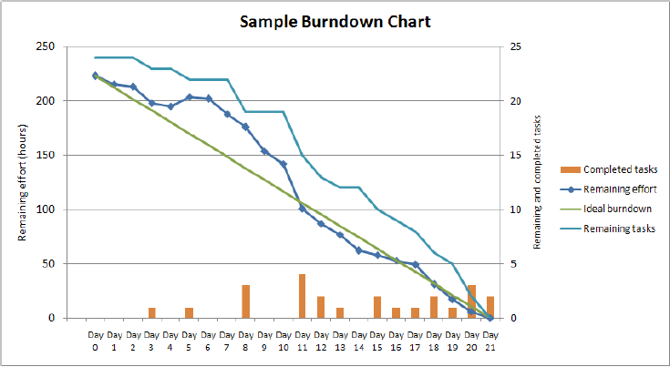

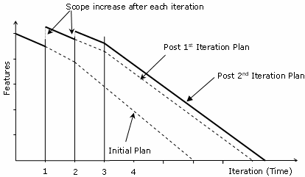

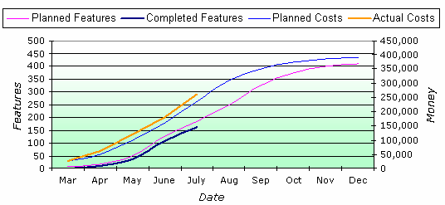

🕮**More AGILE Charts**

##### Value-Based Analysis

Consider business value of work items to act; understand value, consider: •Development+ delivery cost - early high-level estimate of backlog items to compare benefit-cost then determine priority •Payback frequency= value generated once or frequently

**Value-based Decomposition and Prioritization** •Elicit stakeholders’ requirements •Rank requirements •Prioritize requirements (development) **Tricks of the trade** •Refine requirements from backlog into iteration goal •Refine iteration goal requirements into iteration plan & user stories •Refine user stories requirements with discussions, stand-up

**Value-based Decomposition and Prioritization steps** ❶Design Product Box (High-level vision, align stakeholders behind common mission, goals, success criteria) ❷Feature workshops (break down vision into potential features) ➌Candidate feature list ❹Iterative development cycle for prioritized feature list **Parkinson’s Law** - Work tends to expand to fill the time available **Student Syndrome** - Given deadline, people tend to start at near deadline **Progressive elaboration -** refine plans as more details emerge

**Agile Plans** ❶Trial & demonstration uncover true requirements requiring planning ❷Agile planning less an upfront effort, more throughout project ➌Midcourt adjustments = norm

**Built-in feedbacks in planning** ❶Backlog reprioritization affects iteration/ release plans ❷Iteration feedbacks generate change request+ new requirements ➌Retrospective generate changes to processes+ techniques

**Agile Charters** ❶Project’s goal, purpose, composition, approach ❷Authorization from sponsor ➌Recognize scope change by characterizing the goals envisioned for the project ❹Describe processes and approaches for iterating toward the final product ❺Acceptance criteria to verify the project outcomes [**What** is this project about? (High-level vision, mission, goals, objectives) **Why** is it being undertaken? (Business rationale) **When** will it start and end? **Who** will be engaged? (project participants + stakeholders) **Where** will it occur? (work sites, deployment requirements) **How** will it be undertaken? (approach, changes from traditional)]

**Business Case** •Project overview •Anticipated costs/ benefits •Business models/ indexes (ROI, IRR, NPV) •ROI assumptions/ risks associated •SWOT/PEST (Political, Economic, Social, Technical) •Sponsor’s recommendation (mandatory, critical, nice-to-have)

##### On Quality

**Reduce problem’s position** on **cost of change curve**: pair programming, test-driven development, acceptance test-driven development

**Escaped defects** are not discovered during testing & validation; are top of “Cost of change” graph

“**Fitness for purpose**” = Implied warranty

**Monitor/assess quality of project processes** with tools: •Defect metrics •Variance and trend analysis •Root cause analysis •Corrective actions

**Quality standard practices ❶**Measure product quality by tests passes and customer acceptance ❷Automate tests if possible ➌Test during each iteration ❹Fix minimum 90% defects in next iteration ❺Quality control & assurance side-by-side with developers and business ❻Testers collaborate with developers on finding defects & reproducing error ❼Only business can declare defect as fixed

###### Failure and Success

**Failure modes** **❶**Make mistakes human nature ❷Prefer to fail conservatively-revert to what they know ➌Invent rather than research ❹Creatures of habit ❺Be inconsistent

**Success modes** **❶**Good @ looking around ❷Can learn ➌Be malleable ❹Pride in work

**Strategy ❶**Counter with discipline & tolerance ❷Start with concrete & tangible ➌Copy & alter ❹Watch & listen ❺Support concentration & communication ❻Personality-matched work assignment ❼Talent ❽Rewards for long-term, self-esteem based motivators: pride-in-work, pride-in-accomplishment ➒Combine reward ➓Feedback

###### Deming and Testing

**Deming’s mistakes** **❶**React to common-cause-variation outcome as if special cause ❷Treat special-cause variations as if common cause **Solution** •Accept common-cause variations, intervene on special-cause •Avoid micromanagement, remove bottlenecks & impediments •Avoid tracking conformance, look to external indicators & daily stand-ups

**Test-driven development** red, green, refactor // write test, write code, refactor **Benefits** ❶Focus on outcome and customer ❷Good test coverage enhances quality ➌ Early defect catching ❹Small tested units ⇨ Modular, flexible, extendable **Costs** ❶Tests written by coder suffer same misinterpretations ❷Functionality types e.g. user interfaces difficult/time consuming to test ➌ Test maintenance is costly ❹False sense of security with more tests

###### Acceptance Test-Driven Development (ATDD)

Testing focus from code to business requirements 4 stages: ❶Discuss requirements ❷Distill tests in framework-friendly format ➌ Develop code and hook-up tests ❹Demo

**Investigation steps:** gather data, generate insights - decide what to do

**Control limits** = visual controls **Continuous integration** = software integrating new & changed code **Components** ❶Source code control system ❷Build tools ➌Test tools ❹Scheduler/trigger ❺Notifications **Benefits** ❶Early warning of conflicts ❷Problems fixed at integration not on release ➌ Immediate feedback on system-wide impacts ❹Frequent unit test ❺Easy reversion if problems

**Cycle time** = time for work from start to finish = WIP/Throughput

**Risk-based spike** = short period of Proof of Concept

SMART goals specific, measurable, attainable, relevant, timely

**Fast failure** finding fatal design flaws early

**Gather data** use **timeline** (timeline with good, problematic, significant)

**Decide about problems** short subjects, smart goals, retrospective planning games

##### Retrospectives

**Stages of executing retrospectives** set stage, gather data, generate insights, decide what to do, close retrospective

**➊Set the Stage** (Check-in, Focus on/Focus off, ESVP = Explorer-Shopper- Vacationer-Prisoner, Working agreements) **➋Gather Data** (Timeline, Triple nickels, Color code dots, Mad-sad-glad, Locate strengths, Satisfaction histogram, Team radar, Like to like) **➌Generate Insights** (Brainstorm, Five whys, Fishbone, prioritize with dots, Identify themes) **➍Decide what to do** (Short subjects, SMART Goals, Circle of questions, retrospective planning game) **➎Close retrospective** (plus/delta, helped-hindered-hypothesis, return on time invested, appreciations)

##### Success, Anti-Pattern

**Continuous improvement** is core to pair programming, daily stand-ups, demos-reviews-retrospectives

**Process anti-Patterns** (Bad things): ❶One size for all project (no optimal methodology) ❷Intolerant (people can choose) ➌Heavy (too much artifacts and practices divert people from real goals) ❹Embellished (get to know what people won’t do even when not admitting to) ❺Untried (better reuse, adjust, tune and create what is needed) ❻Used once (better than untried but not yet perfect)

**Success process signs** ❶Projects get shipped ❷Leadership remains intact ➌People on the project work the same way

**Successful methodologies** ❶Interactive, face-to-face communication is cheapest, fastest communication ❷Excess methodology weight is costly ➌Larger teams need heavier methodologies (more knowledge needs be committed to documentation with larger projects) ❹Greater ceremony for projects with greater criticality (more rigor with more critical project) ❺Increasing feedback & communication reduces the need for intermediate deliverables ❻Discipline, skills & understanding counter process, formality & documentation ❼Efficiency expendable in non-bottleneck activities: look for constraints, resolve bottleneck otherwise any improvement worthless

##### PMI codes

**➊Responsibility** •Make decisions based on company’s best interests •Protect proprietary information •Report unethical behavior and violations **➋Respect** •Maintain an attitude of mutual cooperation •Respect cultural differences •Negotiate in good faith •Deal directly with conflict •Do not use position to influence **➌Fairness** •Act impartially without bribery •Look for and disclose conflicts of interest •Do not discriminate •Do not use your position for personal/business gain **➍Honesty** •Understand the truth •Be truthful in all communications

#### Traditional versus AGILE

|  |  |  |  |
| --- | --- | --- | --- |
| **Traditional** | **Agile** | **Traditional** | **Agile** |
| Integration Management | | Scope Management | |
| ⬩Project plan development  ⬩Plan execution  ⬩Direct, manage, monitor, control  ⬩Integrated change control | ⬩Release & iteration planning  ⬩Iteration work  ⬩Facilitate, serve, lead, collaborate  ⬩Constant feedback + ranked backlog | ⬩Scope definition  ⬩Create WBS  ⬩Scope verification  ⬩Scope change control | ⬩Backlog +planning  ⬩Release + Iteration plans (FBS)  ⬩Feature acceptance  ⬩Constant Feedback and Ranked backlog |
| Quality Management | | Risk Management | |
| ⬩Quality planning  ⬩Quality Assurance  ⬩Quality Control | ⬩Definition of “done”  ⬩QA involved from beginning + Review and Retrospectives  ⬩Test early/ often; feature acceptance | ⬩Risk identification, qualitative analysis, response planning  ⬩Monitoring & Controlling | ⬩Iteration planning, daily stand-ups and retrospectives  ⬩Daily stand-ups + visible information radiators |

#### Agile versus Waterfall

##### Integrating AGILE with WATERFALL

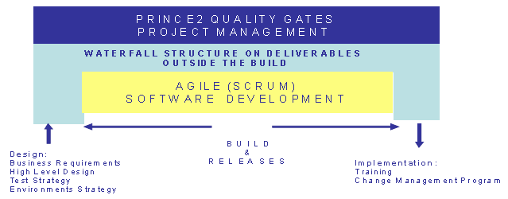

##### Planning

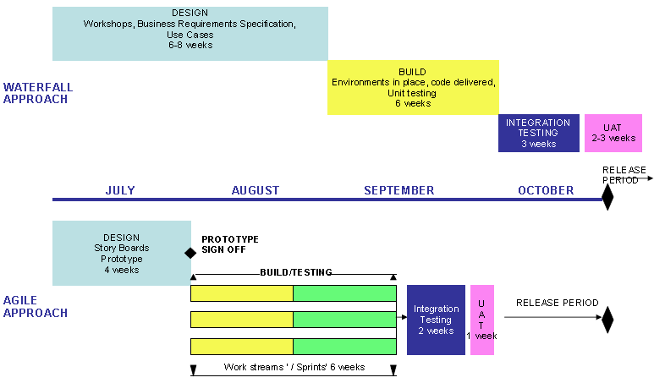

##### Deliverables

|  |  |  |
| --- | --- | --- |
| **Phase** | **Waterfall** | **Agile (Scrum)** |
| **Initiation** | ⬩Project charter ⬩Project Initiation Document (PID) ⬩Contracts | ⬩Project charter ⬩Project Initiation Document (PID) ⬩Contracts |
| **Design** | ⬩Business Requirements ⬩Specification (BRS) ⬩Functional Specification ⬩Environment Strategy ⬩High-Level Design ⬩Test Strategy ⬩Training Strategy | ⬩Product Catalogue ⬩”Brown Paper” sign-off at end of session ⬩Prototype signoff ⬩Use Cases (not in critical path only for references) |
| **Build** | ⬩Detailed Design ⬩Test Plan ⬩Code | ⬩High-level test strategy (reference) ⬩High-level design (parallel with development) ⬩Show-and-tell SW packages at end of Sprint |
| **Implement** | ⬩Training Plan ⬩Release Plan | ⬩Training Plan ⬩Release Plan |

##### Resource allocation

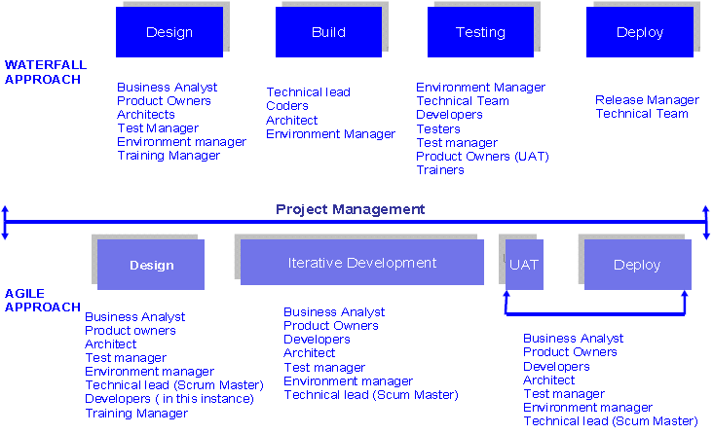

##### Organization

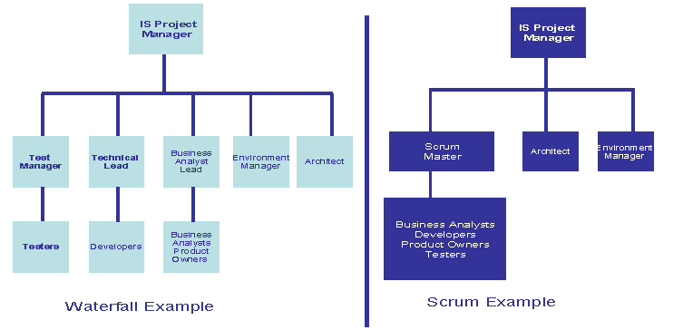

#### Microsoft DYNAMICS SURESTEP AGILE

###### Agile Project Plan

|  |  |
| --- | --- |
| **Diagnostic Phase**  **AGILE Preparation**  1.1.1-Project Planning  1.2.1 Conduct Solutions Overview  1.2.2 Gather User Training requirements  1.3.1 Conduct detailed Business Process Analysis  1.4.1 Gather Business Requirements  1.4.2 Conduct Fit Gap analysis  1.4.3 Define Solution Backlog  1.7.1 Set up development and other non-production environment  1.8.1 Establish Integration Strategy  1.9.1 Gather Data Migration Requirements  **AGILE Execution**  2.1.1 Define SPRINT Backlog  2.1.2 Conduct SPRINT Planning Meeting | 2.1.3 Conduct SPRINT Technical Preview  2.1.4 Conduct SPRINT Post Mortem  3.1.1 Conduct Daily SPRINT Cycle Meeting  3.1.2 Analyze & Design for SPRINT Cycle  3.1.3 Create Scripts for testing  3.1.4 SPRINT configuration & Development  3.1.5 Generate Daily Build  3.1.6 Conduct SPRINT Testing  3.6.1 Conduct Solution Testing  3.7.1 Finalize Production Specification  Deployment  4.1.1 Project Planning  4.2.2 Conduct User Training  4.4.2 Go Live  4.6.2 Conduct UAT  4.7.1 Build Production Environment  4.9.3 Final data migration to Production |

➊**Agile Preparation** project kick-off ⇨ create **Initial Solution Backlog** (initial subset of solution requirements, used to begin development

➋**Agile Execution phase** 2 **Sprint cycles[4]**: ➀**Daily Sprint Cycle** encompassed within ➁**30-Day Sprint Cycle** ⬩Development activities on daily basis (planning, analyzing, designing, developing, and testing) performed against **Sprint Backlog (**compiled list of requirements from **Solution Backlog** broken down into smaller increments of product features) ⬩Requirements in Sprint Backlog broken down into manageable tasks during **Sprint Planning Meeting** ⬩**Sprint Technical Preview** activity at end of Sprint Cycle (implementer & customer teams review developed solution wherein requirements are approved, or rejected, and fed back into the Solution Backlog for possible inclusion in a future Sprint Cycle) ⬩**Sprint Post Mortem (Sprint Retrospective)** evaluates team's performance, discusses opportunities for improvement. After final Sprint Cycle, perform *solution testing* and finalize *specification for production*

➌**Deployment and Operation phase** include **User Training,** **User Acceptance Testing**

###### Conditions for Agile project type

⬩**Fair Degree of Fit**—around 50-75%—with the customer's requirements; customizations medium-to-complex so that development efforts can be encapsulated within Sprint cycles; envisioned solution may include an ISV solution ⬩**Custom code development** may encompass integration or interfaces to 3rd party sources, migration of data from legacy or 3rd-party systems but coding efforts not overly complex ⬩**Business process analysis + OCM activities** may be included and executed in parallel with development ⬩Agile project type typically applicable to **single site** implementations, but may be extended to smaller multisite engagements with **about three locations** ⬩Agile project type requires disciplined control of scope, experienced Scrum Masters or Sprint Cycle Managers, business and IT users experienced in deploying / using business solutions to join solution delivery team

## System Integration

#### 14 Integration Best Practices[5]

➊**Systems Integration Plan** ➋**Matrix (System, subsystems)** defined as **Configuration Items** ⇨ accordingly organize WBS, BOM (Bill of Materials), Schedule ➌**Requirements, Design, Verification specifications** at each system level ➍**Specification trees** (Requirements, Design, Verification) ➎**Traceability** (Requirements, Design, Verification specifications) – (Program plans, development, build, release, verification schedules) ➏**System Integration planning & management methodology** tracks/ documents Configuration Item/ Subsystem progress (min. 1 level of decomposition) ➐**Resources** assigned to Subsystem; **budget synergy** (Systems Engineering, Systems Integration, Development, Test) ➑**Configuration Management (CM)** owns system configuration; all items submitted to Systems Integration through CM ➒**Systems Integration Lab (SIL)** with distinct spaces & equipment for Component Checkout, Subsystem Integration, System Integration ➓**System Architecture Skeleton (SAS)** assembled in SIL for continuous integration activities & incremental alignment ➊**Continuous integration rhythm** defined in System Architecture Skeleton to include *regular system builds*, *regression testing,* *automated test methods* for frequent “smoke tests” ➋**Component checkout** written procedure prior to Subsystem Integration to verify *component interfaces, compliance with derived requirements, boundary checks, error handling, memory leak testing* ➌**Subsystem integration** written procedure prior to System Integration to verify *internal interface, end-to-end, system-level capabilities* ➍**System Integration** written procedure prior to Verification to include *stress testing, long mission thread testing*

*🕮****Data Integration*** *🕮****LIFE Integration*** (system, web services, SOA)

##### Integration Model

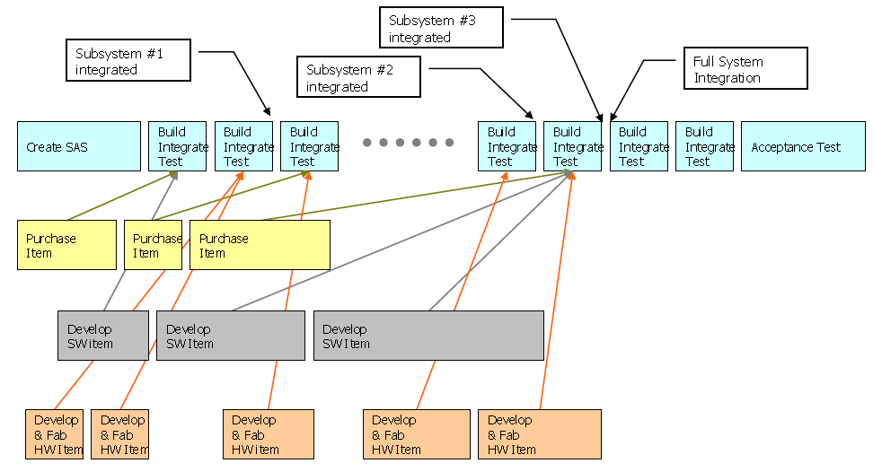

##### System Integration Team & Phases

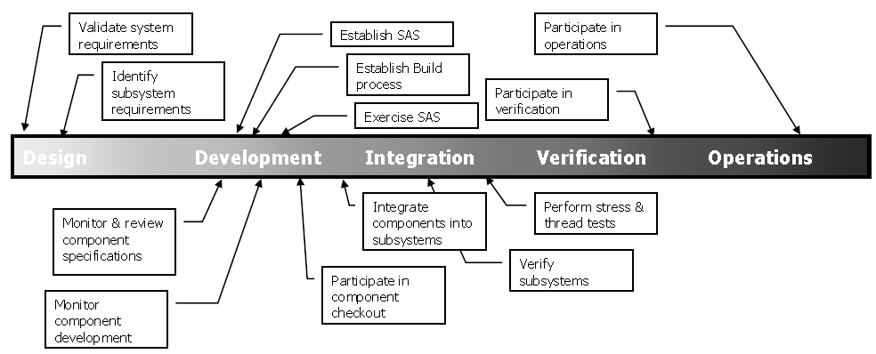

##### Configuration Items (HW/SW) and Subsystems

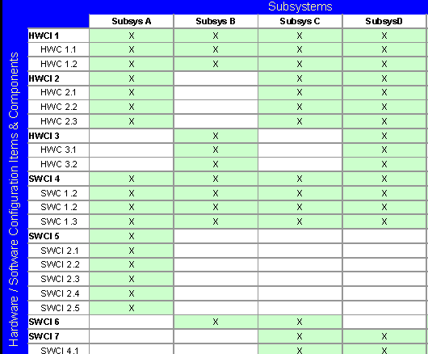

##### Integration tracking

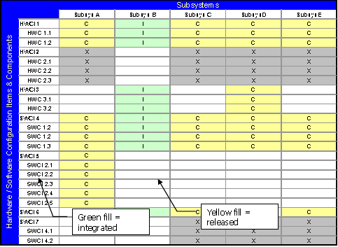

##### Specification trees Requirements & Design

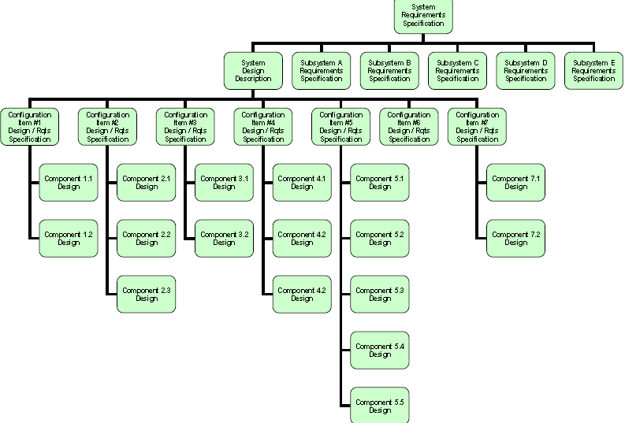

##### Specification Tree – Verification

##### Integration Work Breakdown Structure

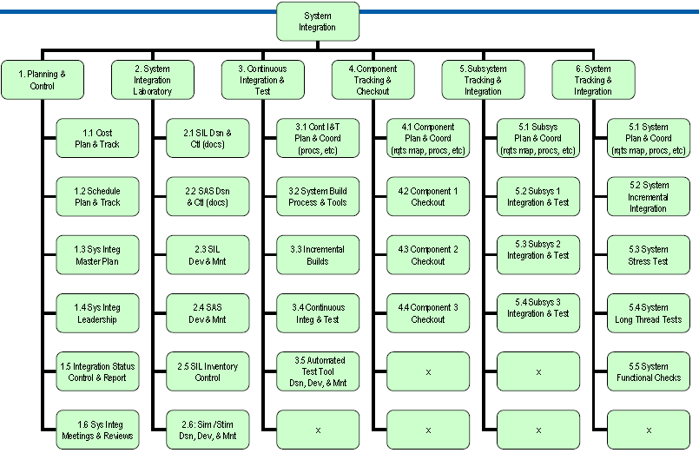

## Software Development Life Cycle (SDLC)

**See UML** **-** **See Traceability Matrix**

[**CASE Study HOOPP upgrade**](#_HOOPP_Upgrade_(jan11-dec11))

#### 10 Phases of SDLC

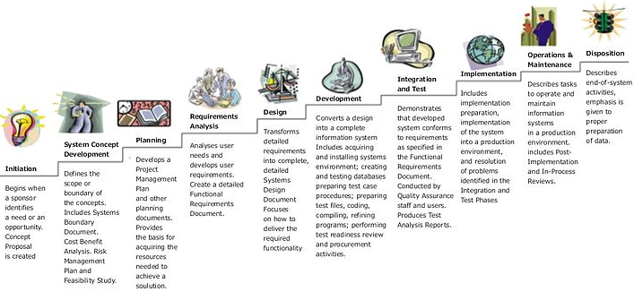

|  |  |
| --- | --- |
|  | Staged Delivery |

##### SDLC Code Growth Pattern

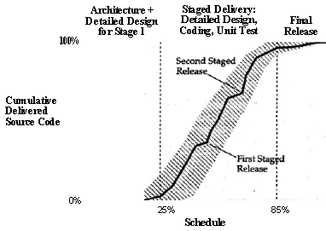

##### Application Testing

# Change Management

## Generics

#### Keywords

•**4P** People, process, product, partner •**Realign org design to change** ➊Shared understanding of reality of change of issues ➋Connect market place realities <with> top management aspirations <with> workplace energy & initiatives ➌Org. capacity to act, reflect, disseminate ➍Forces for change environment, structure – org, technology, people

•**Action plan** ➊Actions to deal with change issues ➋Support for success ➌Who responsible for what ➍Timetable for change ➎Required resources (people, training, financial) ➏Criteria for successful change ➐Monitoring feedback ➑Anticipated modifications to change ➒Change manager - Balanced scorecard – Control

#### FMEA Failure Modes Effect Analysis

⬩Pronounced F-M-E-A or FEMA ➊List key process steps (from highest ranked items of *Cause and Effect C&E matrix)* ➋List potential failure mode for each step ➌**List effects of this failure mode**; if failure mode occurs, what does this mean to us and customer (what effect) ➍**Rate how severe this effect is** (1= not severe, 10= extremely severe) ➎**Identify causes of failure mode/effect & rank it** as in the occurrence column (1= highly unlikely to ever occur, 10= happen all the time) ➏**Identify controls in place to detect issue & rank its effectiveness** in detection column (1= excellent controls, 10= no controls or extremely weak controls) ➐**Multiply severity, occurrence, detection numbers,** store it in RPN (risk priority number) column - used to identify priority (severity= 10 (very severe), occurrence= 10 (happens all the time), detection= 10 (cannot detect it) ⇨ RPN is 1000: all hands on deck, serious issue! ➑**Assign specific actions with responsible persons,** include date to be complete ➒Actions completed ⇨ **re-score occurrence & detection;** do not change severity score unless customer decides this is not an important issue 🕮**FMEA Diagram**

#### Effective change process

➊Formulate the change ➋Plan the change ➌Implement the change ➍Manage change transition ➎Sustain change

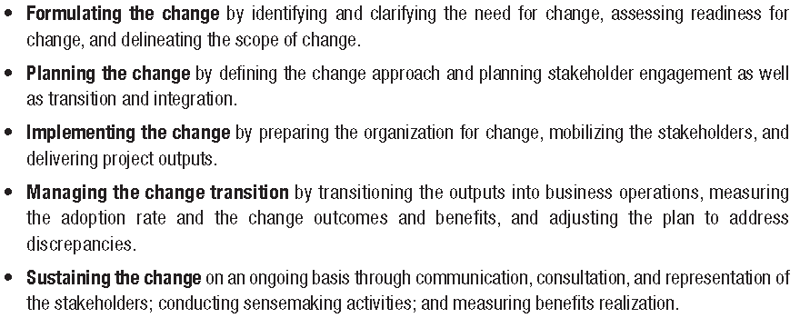

#### Kotter’s Heart of Change

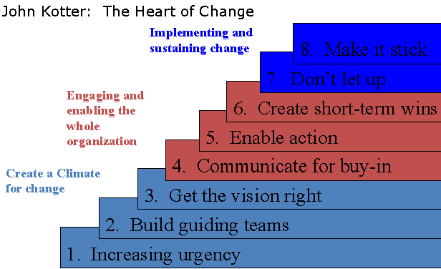

#### Change management specialist

⬩Lead Initiatives & ensure work packages are delivered on time, within budget, and with quality, as agreed to by Project Manager, Client, and / or Sponsor of each initiative ⬩Lead & be responsible for end-to-end management of business work package deliverables within the scope of an overall project, including Business Requirements, Communication and Training strategy (circulars, manual changes, and procedures) ⬩Communicate project objectives, quality control and operational needs of the end users ⬩Lead and Mentor Business Analysts in support of Project work packages deliverables ⬩Process re-engineering support through the use of Lean and Six Sigma tools such as ***FMEA* Failure Modes Effect Analysis** and ***Value Stream******Maps*** relative to the project ⬩Provide estimates of work effort + duration for work package deliverables ⬩Create project plans for assigned work packages with resources, effort, timelines ⬩**Lean/Six Sigma**

## Change In PMI Context

#### Change Management in Portfolio, Program, Project

##### Change Model Systemic - orders of change

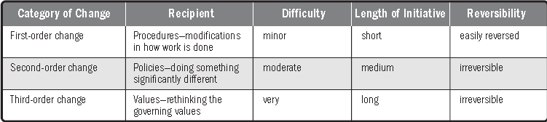

##### Change Management Life Cycle

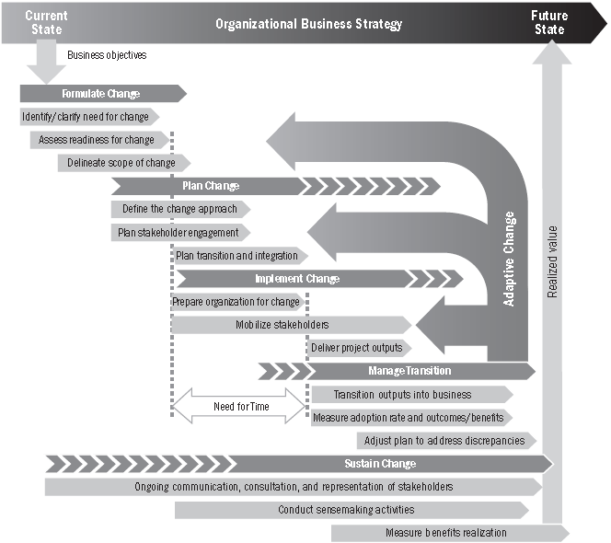

##### Strategic agility through Portfolio, Program, Project

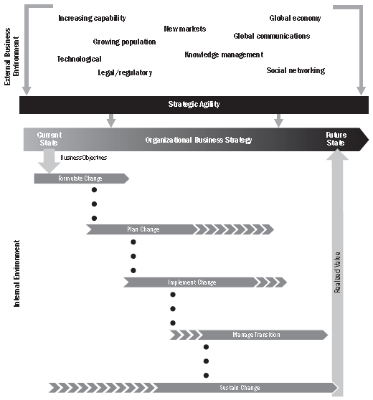

#### Organizational Project Management (OPM3)

##### Strategy, Portfolio, Program-Project, Operations

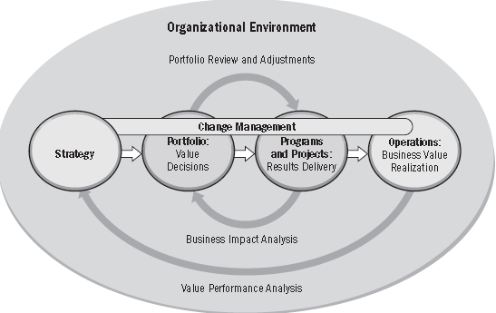

#### Change Management at Portfolio Level

##### Two-way Communication between Strategy and Front-line

**4 legs to manage changes at portfolio level** ➊Communication ➋Traceability ➌Transparency ➍Accountability

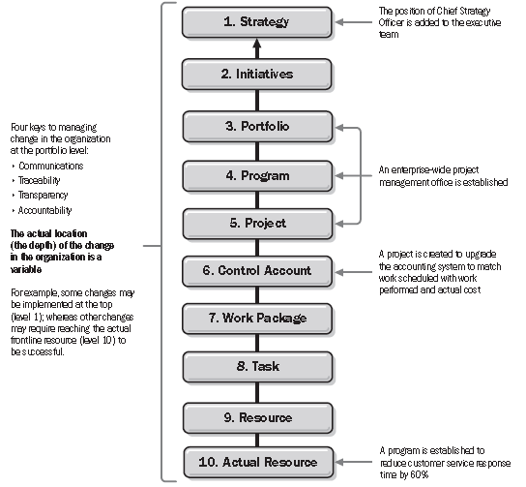

##### Considerations in defining process

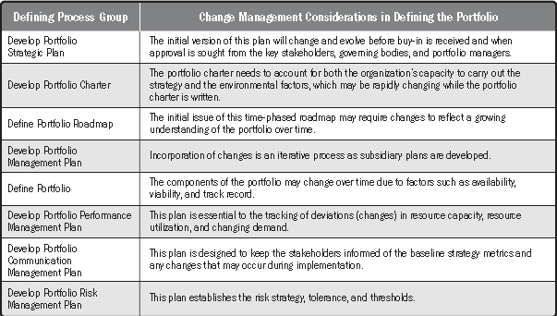

##### Considerations in aligning process

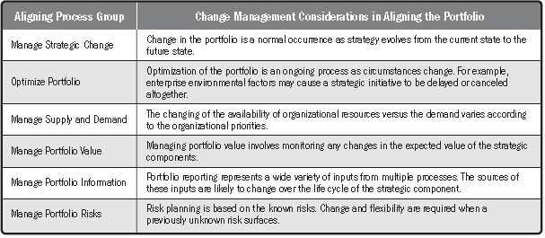

##### Considerations in authorizing and controlling process

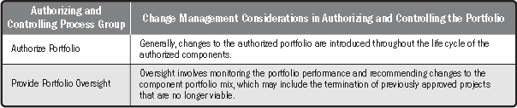

#### Change Management at Program Level

##### Program life cycle vs. Change life cycle

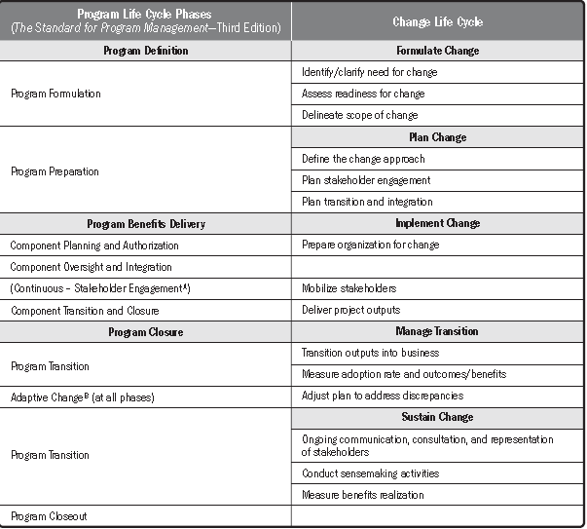

##### Measuring Program Benefits and Critical Success Factors

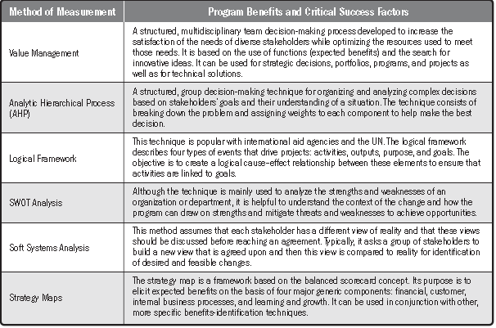

##### Roadmap elements

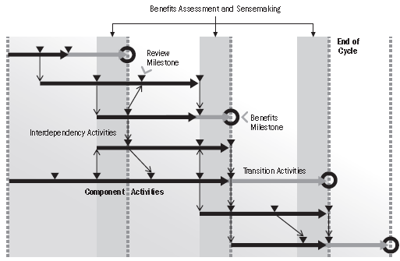

➊Component activities ➋Interdependencies ➌Transition activities ➍Review milestone ➎Benefits milestone

##### Executive-level Benefits Register

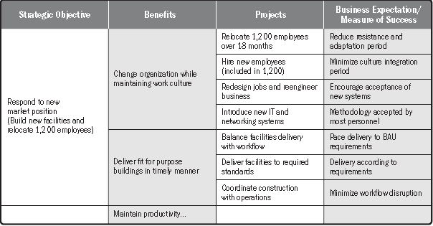

##### Specific activies through Change and Program Life Cycle

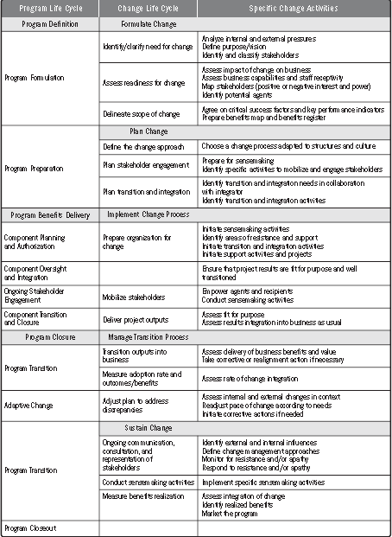

#### Change Management at Project Level

##### Coordinating change, program and project

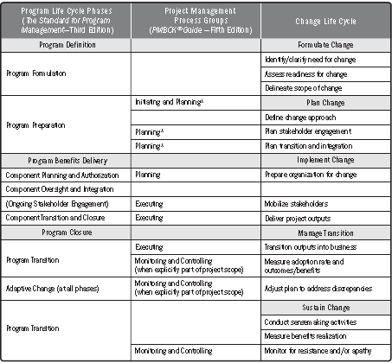

##### Change Management activities & PM Process Groups

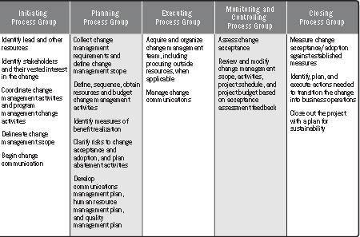

##### Change Management & PM Knowledge Areas

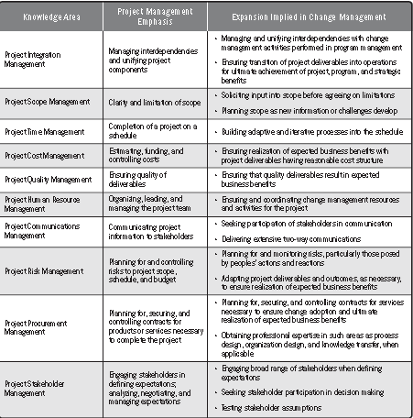

##### Risk Mitigation in Change Management

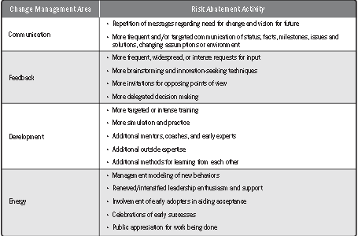

##### Communication Management Plan

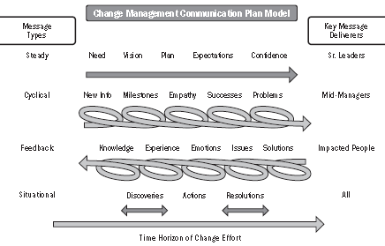

##### Engagement/Communication Plan Structure

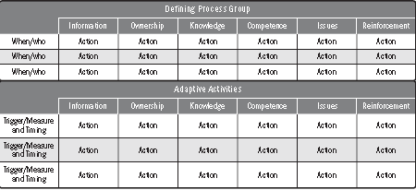

##### Project control

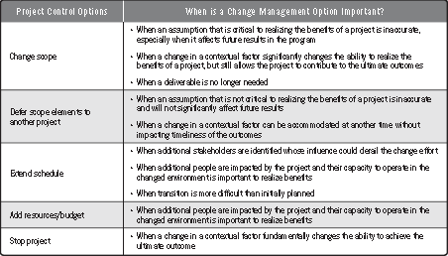

## Lean/Six Sigma

##### DMAIC Tool Map

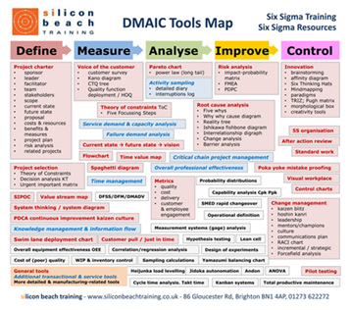

## Activity-Based Costing

#### Booz Allen Cost Transformation

|  |  |  |
| --- | --- | --- |
| **Strategy – Diagnosis & Target Setting** | **Design** | **Implementation** |
| ➊ Determine cost/ performance gap  ➋ Analyze root causes  ➌ Assess improvement potential  ➍ Set target  ➎ Build leadership commitment | ➊ Prioritize improvement areas  ➋ Set up overall program structure  ➌ Develop baseline & cost driver understanding within each initiatives  ➍ Design improvement actions & measures | ➊ Have management lead change  ➋ Develop implementation plans and roll-out actions  ➌ Track progress via program office  ➍ Train staff in new processes  ➎ Adapt metrics and incentives  ➏ Launch communications |

##### Costs versus Strategic Initiatives trade-off

⬩Margin (higher margin market) ⬩Growth ⬩Quality ⬩Service level ⬩Control ⬩Risk assurance ⬩Proprietary Knowledge

##### 4 waves of operations technology improvement

|  |  |  |
| --- | --- | --- |
| **Wave 1** | **Eliminate waste**  **“How well we do it”** | ⬩ **Cost transparency** (where costs are)  ⬩ **Continuous improvement** (Lean manufacturing, Six Sigma) |
| **Wave 2** | **Streamline processes**  **“How we do it”** | ⬩ **Activity-based costing** (managing costs to process)  ⬩ **Process engineering** (end-to-end processing, embedded quality, standardization)  ⬩ **Sales & Operations Planning** (aligning capacity and demand)  ⬩ **Clarification of decision** (operating model, governance, measurement, rewards) |
| **Wave 3** | **Consolidate activities**  **“Where we do it”** | ⬩ **Cost-driver analysis**  ⬩ **Consolidation** (footprint and scale)  ⬩ **Off shoring, outsourcing** (locations and suppliers)  ⬩ **Tailored business streams** (complex versus standard activities) |
| **Wave 4** | **Attack complexity**  **“What we do”** | ⬩ **Product portfolio rationalization**  ⬩ **Product and service architecture** (modularization, standardization)  ⬩ **IT architecture** (scalability, elimination of legacy) |

#### ABC Illustrated

##### ABC Framework Questions

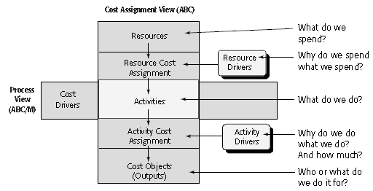

##### Management Accounting Framework

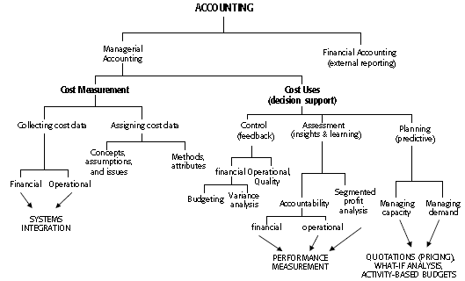

|  |  |
| --- | --- |
| Cost Assignment | Activity Drivers   ***Selecting and tracing activity drivers is much easier after high level final cost objects are defined*** |

##### Activity Cost Assessment Techniques

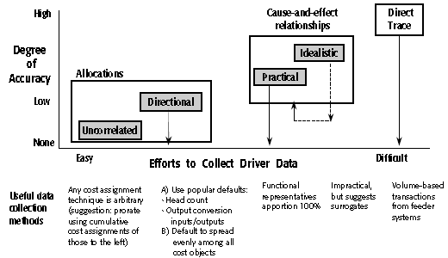

***Only the “vital” few activity drivers need to be downloaded from feeder databases.***

***The remainder can come from estimates. Stay away from illogical allocations***

##### Shared Service Model

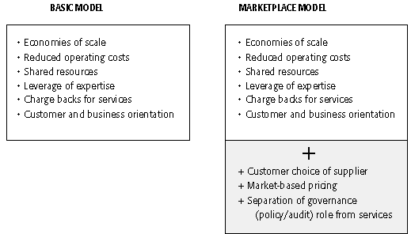

|  |  |
| --- | --- |
| ABC Cost Assignment Model | ABC Terminology ⬩**Resources** Economic elements used to perform activities ⬩**Activity center** cluster of related activities ⬩**Resources Drivers** Factors used to allocate resource or pools of costs to activities ⬩**Activity Cost Pool** Total cost assigned to activity ⬩**Cost Driver** Factor used to assign cost from activity enter to other activity cost pools or cost objects ⬩**Cost Elements** amount paid for a resource and assigned to an activity ⬩**Cost Object** ultimate goal for performing an activity, and in ABC it represents the final cost assigned to a product or service |
|  | |

#### ABC in Insurance

|  |  |
| --- | --- |
| Claims process | Major Cost Categories  Processing cost – applications  Processing cost – claims |

#### ABC in Banking

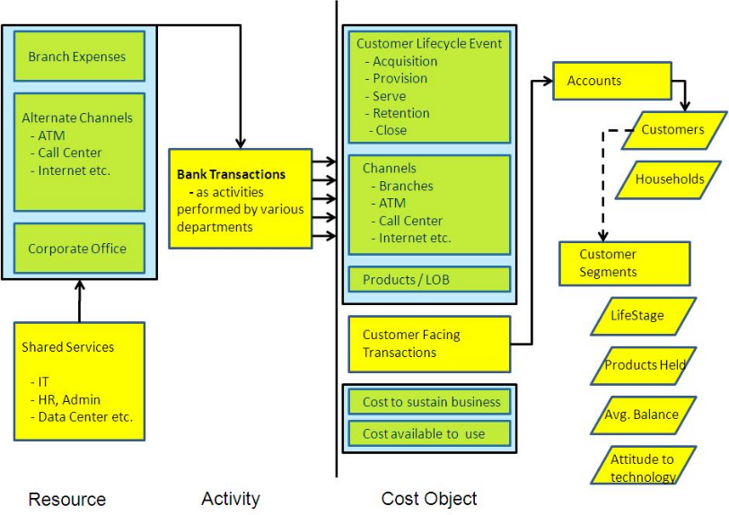

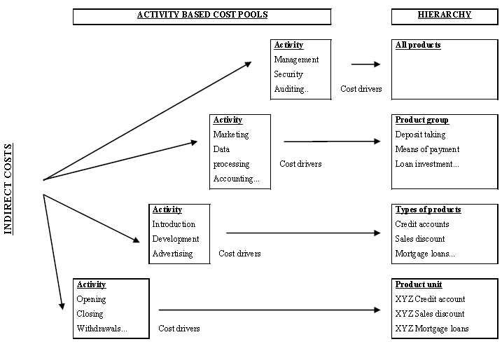

#### PeopleSoft Activity-Based Management PeopleBook

**Questions** (costs of serving clients? most profitable customers, products, channels? opportunities to reduce costs? what products/ services to divest or invest?)

**Features** ⬩Setting Up Attributes, Cost of Capital, Resources, Ledger Mapping Rules ⬩Setting Up Activities Dimensionality, Consumption Patterns, Sustaining Activities) ⬩Setting Up Cost Objects ⬩Setting Up Drivers attributes, rates, source/target models ⬩Real-time vs Batch activity-based managemnet ⬩Employee profile, operational warehouse, activity fragmentation ⬩Model service-based industries with Bill of Services

**Activity-Based Management Modeling Components** ⬩**Resources** (people, facilities, costs associated with people + expenses—economic elements consumed while performing activities ⬩**Activities** consume resources & drive costs to cost objects ⬩**Cost objects** cost information grouped by profitability dimensions—products, customers, channels ⬩**Ledger mappers** relate expense data from general ledger accounts to resource objects - Map

multiple ledger line item amounts to 1/more resource IDs •Actual amount that represents actual costs of accounting period results •Budgeted amount to calculate capacity rates as well as budgeted model results ⬩**Drivers (**transactional, duration, and intensity) to assign monetary amounts from one object to another throughout the model (calculated by amount, percentage, spread even, and direct) in different ways depending on assignment type and object type ⬩**Pointers** specify location of driver quantities in Operational Warehouse - Enriched (OWE) tables Rate options for model types •Actual •Budgeted •Capacity •Frozen •Combination ⇨ Create/ run basic, full-absorption models •to calculate variances from actual costs such as spending, volume, and capacity variances •to attribute monetary amounts to entities that operate at greater than or less than their capacity •to maintain a more constant consumption pattern over multiple time periods

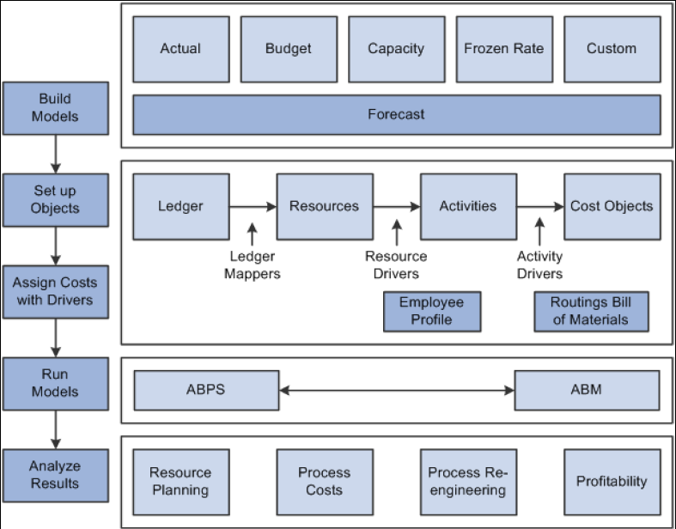

# 

1. FMEA = Failure Modes & Effects Analysis
2. **Wideband Delphi** **Steps**: ❶Break a problem into manageable chunks ❷Define problem specification, assumptions, constraints ➌Outline process for *next rounds* of estimation
3. **Planning Poker**: card showing the Fibonacci sequence, representing sizing units (to reflect the inherent uncertainty in estimating larger items) including a zero: 0, 1, 2, 3, 5, 8, 13, 21, 34, 55, 89; other decks use similar progressions or the sequence: 0, ½, 1, 2, 3, 5, 8, 13, 20, 40, 100, and? (unsure)
4. **Sprint cycle** a.k.a. **Scrum** denotes a time period, up to *4 weeks in duration*, in which the team develops the solution on an identified set of backlog items
5. From Northrop “Best Practices for Systems Integration”, 2011